Zooplankton characteristics across a western boundary current influenced continental shelf

Hayden T. Schilling1,2, Jason D. Everett2,3, Amandine Schaeffer4, Peter Yates1,2, Mark E. Baird5, Iain M. Suthers1,2

1Sydney Institute of Marine Science, Chowder Bay Road, Mosman, New South Wales, Australia

2Centre for Marine Science & Innovation, University of New South Wales, High Street, Kensington, New South Wales, Australia

3Centre for Applications in Natural Resource Mathematics (CARM), School of Mathematics and Physics, University of Queensland, Brisbane, QLD, Australia

4School of Mathematics and Statistics, University of New South Wales, High Street, Kensington, New South Wales, Australia

5Commonwealth Scientific and Industrial Research Organisation, Castray Esplanade, Battery Point, Tasmania, Australia

Corresponding author: Hayden T. Schilling ([h.schilling@unsw.edu.au](mailto:h.schilling@unsw.edu.au))

Abstract (262 words, probably too long)

Zooplankton are an important food source for pelagic ecosystems. Previous studies have identified horizontal variation in the zooplankton community across continental shelfs but there is limited information on vertical distributions. Western boundary currents are known to influence continental shelf waters through a variety of physical mechanisms including bottom water intrusions and coastal upwelling which also influence the planktonic community. Using an optical plankton counter and CTD mounted on an undulating towed body in waters, this study presents the first high-resolution depth-resolved profiles of the zooplankton community across a continental shelf. We show that zooplankton biomass is highest inshore with biomass declining with both increasing distance from shore and depth. The front between the warm East Australian Current (EAC) and cooler continental shelf waters also showed increased biomass of zooplankton showing the dynamic nature of coastal water masses. The EAC influenced the continental shelf waters by creating current driven uplift influenced zones. This uplift caused the zooplankton communities tended to be smaller and more productive with smaller geometric mean sizes and steeper estimated normalised biomass size spectrum slopes. South of the EAC, the continental shelf zooplankton community was more homogenous but still displayed the same broad horizontal and vertical patterns in zooplankton. The patterns observed in this study align with previous research on zooplankton distributions on continental shelves and we suggest that globally inner continental shelf regions more productive and support high biomasses of zooplankton compared to offshore, particularly where uplift may be a common occurrence. This may be a driver of the highly productive fisheries which are often found on continental shelfs.

1 Introduction

Western boundary currents (WBCs) are fast-flowing currents which transport warm salty water from the tropics to the poles. At a broad scale, WBCs flow along continental boundaries generally inhibiting cross-shelf transport due to their strong along-shore flows (Roughan *et al.*, 2011). At a smaller scale, WBCs interact with the continental shelves to generate eddies, fronts and upwelling that can increase transport across the shelf (Malan *et al.*, 2020). By increasing upwelling of cold water on the continental shelf (Schaeffer *et al.*, 2013), WBCs contribute to production through the supply of nutrients normally found in cooler deeper water (Pereira Brandini *et al.*, 2014).

Oceanographic features are key drivers in the distribution of zooplankton (Coyle and Pinchuk, 2002; Skarðhamar *et al.*, 2007). The distribution of zooplankton is the result of a number of factors including physical mechanisms such as transport and retention, biological factors including prey availability and predator abundance as well as behaviour of the zooplankton (Huntley *et al.*, 2000). Higher zooplankton biomass on the continental shelf compared to nearby offshore regions has been observed in the southeast Atlantic (Marcolin *et al.*, 2013), northeast Atlantic (Sourisseau and Carlotti, 2006; Irigoien *et al.*, 2009; Vandromme *et al.*, 2014) and southwest Atlantic (Pereira Brandini *et al.*, 2014). While this increase in biomass in nearshore environments is thought to be enhanced by increased nutrients from terrestrial discharge, the influence of terrestrial inputs varies between regions and some regions such as eastern Australia are known to have relatively small terrestrial influences when compared to other sources of nutrients such as upwelling (Apte *et al.*, 1998; Dai and Trenberth, 2002).

Despite the investigation of spatial patterns of zooplankton across continental shelves, few studies have examined patterns of zooplankton with depth on continental shelves. Off New York, during late summer it was observed that vertical zooplankton abundance was strongly influenced by water mass with distinct zooplankton communities separated by a strong thermocline (Turner and Dagg, 1983). This is contrasted by a winter study on the Abrolhos Bank where, on the shelf, copepod abundance peaked near the surface (20 – 40m) and decreased with depth (Marcolin *et al.*, 2015). Recently it has been suggested that light availability and predation by fish may be significant drivers of zooplankton depth distributions (Aarflot *et al.*, 2019).

Zooplankton are an important trophic link (Libralato *et al.*, 2006). As prey for zooplanktivorous fish, zooplankton transfer energy up the food web to higher trophic levels (Marquis *et al.*, 2011; Champion *et al.*, 2015) with zooplankton supporting up to 53 % of fish biomass on temperate coastal reefs (Truong *et al.*, 2017). Predator-prey interactions involving zooplankton are usually driven by body size (Barnes *et al.*, 2010), and by focusing on the size distribution of the zooplankton community, complex species-specific dynamics can be simplified (Blanchard *et al.*, 2017). One method of analysing community size structure is the Normalized Biomass Size Spectrum (NBSS; Kerr and Dickie, 2001). Using a linear fit of normalized biomasses in logarithmically equal size bins, the structure of the zooplankton community is quantified, with a general overall slope of -1 observed in the open sea (Sheldon *et al.*, 1972; Baird *et al.*, 2008). A steeper slope with a large fraction of small particles generally infers higher production and predation while a shallow slope often represents lower predation and less ‘top-down’ pressure (Moore and Suthers, 2006; Blanchard *et al.*, 2017). While widely used, the linear fit for the NBSS is sometimes bias by size classes containing no particles due to small sample sizes and it has been shown that the shape parameter *c* of a Pareto distribution is highly correlated to the NBSS slope and provides a more robust estimate of the NBSS slope for smaller samples (Vidondo *et al.*, 1997; Suthers *et al.*, 2006).

In the southeast Atlantic, the zooplankton community on the continental shelf had higher biomass and a steeper NBSS slope compared to the offshore oceanic stations which were typically more vertically stratified (Marcolin *et al.*, 2013). This is similar to the northeast Atlantic where high zooplankton biomasses and steeper NBSS slopes were found in some but not all inshore regions (Sourisseau and Carlotti, 2006; Irigoien *et al.*, 2009; Vandromme *et al.*, 2014). Smaller scale processes such as island wakes also produce variations in zooplankton community structure as they create areas with potentially more retention and production (Wolanski and Hamner, 1988; Rissik *et al.*, 1997). In the tropical Coral Sea, it was shown that zooplankton communities have higher abundances and a steeper NBSS slope in the wake of islands compared to in the free stream, with the difference attributed to both increased production and predation by fish removing larger zooplankton (Rissik *et al.*, 1997; Suthers *et al.*, 2006).

Despite the previous research on cross-shelf distributions of zooplankton and targeted studies on smaller scale effects such as island wakes, there remains little knowledge about how WBCs effect zooplankton communities on temperate continental shelfs, particularly in terms of the depth structure. This lack of knowledge is particularly prevalent in temperate eastern Australia where there has been no research into cross-shelf patterns of zooplankton. We aim to fill this knowledge gap by describing cross-shelf and depth stratified patterns in the zooplankton community by using a case study of four depth stratified, cross-shelf transects of zooplankton on the eastern continental shelf of Australia to:

1. Identify latitudinal differences in zooplankton distribution across a continental shelf in a WBC region, and
2. Identify potential drivers of the observed patterns in zooplankton biomass, size and productivity and propose a general concept of zooplankton distribution on a WBC influenced continental shelf.

2. Materials and Methods

*2.1 East Australian Current*

Flowing poleward from the Coral Sea, the East Australian Current (EAC) is a baroclinic jet which forms between 10 and 20 °S when the South Equatorial Current diverges against the Australian coast. The southward flowing component, the EAC, flows at approximately 0.5 – 1 m s-1 along the continental shelf (Archer *et al.*, 2017) until the majority of the EAC separates from the coast at approximately 30 – 32 °S and continues to flow eastward as the EAC eastern extension (Cetina-Heredia *et al.*, 2014; Oke *et al.*, 2019). The remaining portion of the EAC continues to flow south along the coast as part of the EAC southern extension generating a large eddy field (Everett *et al.*, 2012). Along the continental shelf, particularly where the continental shelf narrows, the EAC has significant impact on shelf circulation (Schaeffer and Roughan, 2015). Current driven bottom friction leads to Ekman transport in the bottom boundary layer, moving cooler denser water up the slope, resulting in uplift of isotherms and upwelling (Schaeffer *et al.*, 2014). These intrusion events have been shown to bring nutrient rich water into the euphotic zone, increasing nitrate (Rossi *et al.*, 2014) and chlorophyll *a* concentration (Everett *et al.*, 2014), and controlling vertical phytoplankton abundance, composition and distribution (Armbrecht *et al.*, 2014, 2015).

*2.2 Voyage details*

From 2nd – 13th September 2004, a research voyage on the on the RV Southern Surveyor was undertaken from Sydney, Australia (33.82° S, 151.29° E) to Brisbane, Australia (27.36° S, 153.17° E). During this period, the EAC was flowing southward along the coast until approximately 31 °S where it separated from the mainland and continued flowing to the east. This separation resulted in the formation of a large warm-core eddy forming off the coast at approximately 33° S, 155° E (Figure 1).

*2.3 Sampling*

Four constant latitude transects were sampled roughly perpendicular to the north NSW coast over a seven-day period (6th – 12th September; Table 1, Figure 1) using a towed device called the Bunyip (a highly modified SeaSoar). The Bunyip was towed from inshore to offshore and undulated between 10 and 120 m depth. Mounted on the Bunyip was a XXCTDXX and an Optical Plankton Counter (OPC; Herman 1992) to measure temperature, salinity and the size distribution of particulate matter. The ship was also equipped with an R. D. Instruments VM-150 ADCP which continuously monitored the velocity of water beneath the vessel. Alongshore and cross-shelf velocity of currents was calculated by rotating the U and V vectors to account for the angle of the coastline at each location (Table 1). The shelf sampling was interrupted on the 8-10th September to undertake a wake study around North Solitary Island (29.92° S, 153.38° E) which will be reported elsewhere.

*2.4 Zooplankton Data*

The OPC was a Focal Technologies Corporation Model OPC-2T with a sampling aperture of 2 x 10 cm. The OPC records equivalent spherical diameters (ESD) of particles that pass through the instrument in 0.5 s intervals. The particle sizes were recorded digitally using 4096 size bins, corresponding within the operating range of the instrument to bins with a width varying between 5 and 15 µm.

The volume of flow through the sample region was based on distance measured over a 6 s interval. It has been previously shown that a 6 s interval provides the best possible vertical and horizontal resolution (≈ 6 m vertically) of the size distribution in the Tasman Sea region, near the current study area (Baird *et al.*, 2008). To quantify the zooplankton community, several metrics were calculated for each interval of our transects. These included total biomass (mg m-3), geometric mean size (GSM; µm ESD) and the shape parameter *c* of the Pareto distribution of the particles which is an estimate of the NBSS slope. The Pareto distribution has been previously used in this region to spatially resolve the size distribution of particles (Baird *et al.*, 2008).

The Pareto distribution has a probability density function (*pdf*) defined as:

$$pdf(s)=ck^{c}s^{-(c+1)}$$

where *s* is the size of the particle, and *c* and *k* are the distribution’s shape and scale parameters, respectively (Vidondo *et al.*, 1997).

*2.5 Other Environmental Data*

To investigate environmental conditions leading up to and during the sampling of transects on the east Australian continental shelf, MODIS-Aqua Level 3 ocean-colour data (chlorophyll-a) were obtained from the Integrated Marine Observing System (IMOS) Data Portal (<http://imos.aodn.org.au/imos/>) at 1 km resolution. Chlorophyll-a was derived using the OC3 algorithm. Sea surface temperature was obtained from L3S AVHRR daily night product from the same portal, displayed as a map for the region (resolution of 0.02o). Surface geostrophic currents were derived from gridded sea level gradients from satellite altimetry, also taking into account sea level gauges to improve the estimate in coastal area (resolution of 0.2o). To investigate lead-up conditions to our sampling, MODIS chlorophyll-a data were retrieved for 5x5 pixels (~25 km2) surrounding the western and eastern edges of each transect, for the month prior to the day of sampling.

To investigate the seasonal variation of the EAC strength in the region of our transects, 10 years (2004 – 2013) of surface geostrophic currents from satellite altimetry were obtained from the IMOS Data Portal (<http://imos.aodn.org.au/imos/>) for each of our transects. Alongshore and cross-shelf velocity of currents was calculated by rotating the U and V vectors to account for the angle of the coastline at each location (Table 1). The monthly mean (and SD) alongshore velocity was calculated for the 10-year period by averaging the daily velocities. The assumption being that faster alongshore velocity would be due to increased influence of the EAC.

To investigate the potential influence of wind driven circulation, wind data was extracted from Coffs Harbour meteorological station from the Bureau of Meteorology (-30.311, 153.118,) located close to shore at 5 m height. The hourly wind stress was calculated following Wood *et al*. (2016). Bathymetry data was sourced from GEBCO (GEBCO Bathymetric Compilation Group, 2019).

*2.6 A global context*

To place our east Australian transects in a global context and identify general trends in zooplankton communities on continental shelves, we examined previous studies which investigated spatial changes in zooplankton communities over continental shelf regions. We identified 12 additional studies which investigated changes in zooplankton communities over continental shelves and where possible from each study we extracted values for total zooplankton biomass, abundance and the NBSS slope from the most inshore (≤50m bathymetry) and furthest offshore sites (≥200m bathymetry; Table S1). From each study we extracted a maximum of one inshore-offshore value, averaged across the study. An exception was two studies from the Bay of Biscay (Irigoien *et al.*, 2009; Vandromme *et al.*, 2014), where the east and south regions were identified as very different zooplankton communities so there were kept as distinct regions. If there were multiple years or seasons within a study, an overall average was taken. As many studies only provided binned values or plots, data were extracted from plots and binned data were assigned values equal to the mid-point of the bin. As the studies reported a range of units, to make studies comparable in terms of inshore to offshore trends we present the ratio of inshore to offshore values.

3 Results

*3.1 Regional Oceanography*

The three northern most sites (north of 30°S) all crossed from cool inshore waters into warm (>21 °C) EAC water (Figure 1). This is contrasted by the southern transect (Diamond Head 31.75°S) transect which was located south of the separation zone in cooler (<19.5 °C) waters and did not cross into EAC waters. All transects showed low chlorophyll levels (<1.4 mg m-3; Figure S1) which was representative of the previous month of low chlorophyll-a at these locations (Figure S2). There were negligible effects of wind on circulation in the 3 days prior to the transects (Figure S3), with most of the wind coming from a southerly direction.

*3.2 Cape Byron (28.6°S)*

The northernmost transect at Cape Byron (28.6°S) was dominated by the EAC which had a strong alongshore flow (1.50 m s-1) centred over the 200 m isobath (27.6 km offshore). Most of the continental shelf was flooded by warm EAC water (Figure 2). The shipboard ADCP showed slight onshore movement of the EAC which increased offshore and with depth, peaking between 100 and 200m depth (up to 0.26 m s-1, Figure S4). The strong EAC flow resulted in strong current-driven uplift of the isotherms inshore of the EAC with the 21 °C isotherm rising to the surface from 70 m depth over 5 km and the 20 °C isotherm rising to the surface from 100 m depth over 15 km.

A decline in zooplankton biomass was observed from both inshore to offshore and from the surface to depth with the highest biomass (~750 mg m-3; Figures 3, S5, S6) observed at the surface ~20 km from the coastline, just inshore of the 21 °C isotherm (Figure 3). This 21 °C isotherm appears to be a strong delineator of both zooplankton biomass and the size distribution of the zooplankton community. The EAC waters, warmer than 21°C and > 1.2 m s-1 southward velocity, were characterised by low zooplankton biomass with a GMS of ≈450 µm ESD (Figure 4) with pareto *c* shape parameter estimate (≈NBSS slope) of between -1 and -1.3 (Figure 5). The cooler water immediately inshore of the 21°C isotherm had a high zooplankton biomass, shallower *c* (-0.9; Figure 5) with large particles (GMS 500 µm ESD; Figure 4)). Further inshore again (15 -17 km from the coastline), in water < 20 °C, biomass remained high (Figure 3), but the particles were smaller (GMS ≈430 µm ESD; Figure 4), resulting in a steeper *c* (≈-1.25; Figure 5).

*3.3 Evans Head (29°S)*

The transect slightly further south at Evans Head (29°S) did not go as far offshore as the other transects but was still largely influenced by the EAC which had a strong along-shore flow (1.47 m s-1) centred 36.1 km from the coast, near the edge of the continental shelf (220 m seabed depth; Figure 2). The EAC showed offshore movement (0.27 m s-1) which increased with distance offshore (Figure S4). There was strong current driven uplift of the isotherms inshore of the EAC with the 21 °C isotherm rising to the surface from 70 m depth over 6 km and the 20 °C isotherm rising to the surface from 100 m depth over 15 km similar to the northern Cape Byron site (28.6° S).

The zooplankton community was strongly related to the water masses along the transect with strong relationships observed with temperature. Around the front between the continental shelf water (< 21°C) and the warm (> 21°C) EAC water the zooplankton community showed a similar GMS of ~450 µm ESD to that observed at the northern Cape Byron transect but had a higher biomass and shallower pareto distribution shape parameter *c* (~-1; Figures 3, 4 & 5). In the cool inshore waters < 20°C, there continued to be high zooplankton biomass (Figure 3), but the community had shifted towards smaller particles which resulted in a steeper *c* (< -1.3; Figures 4 & 5).

*3.4 North Solitary (30°S)*

The transect at North Solitary (30°S) showed the strongest evidence of current driven uplift of any of the transects with the 21 °C isotherm rising to the surface from 70 m depth over 3 km and the 20 °C isotherm rising to the surface from 100 m depth over 10 km (Figure 3). The offshore portion of the transect continued to be dominated by the EAC which had a strong alongshore flow (1.59 m s-1) centred 37.7 km offshore (310 m bathymetry; Figure 2). The EAC had slight onshore movement, in offshore waters 100-150m below the surface (0.15 m s-1; Figure S4). It is possible that there was some influence of wind-driven uplift at this site (Figure S3).

The biomass of the zooplankton community generally decreased with distance offshore and with depth (Figures 3, S5 & S6). The EAC, particularly further offshore, contained low zooplankton biomass with a shallow pareto distribution shape parameter *c* (-0.9) and GMS of ~450 µm (Figures 3, 4 & 5). The 20 °C isotherm was a strong boundary for zooplankton communities with zooplankton in water < 20 °C having relatively low biomass and a much smaller GMS (~400µm ESD) resulting in a steeper *c* (< -1.3). This was particularly evident where the 20°C isotherm reach the surface ~24 km from the coastline (Figures 4 & 5).

*3.5 Diamond Head (31.75°S)*

The most southern transect located at Diamond Head (31.75°S) was not influenced by the EAC which had separated from the coast to the north and as such was characterised by a more homogeneous water mass. Within the transect the, alongshore velocities are low (< 0.43 m s-1, Figure 2) with low onshore movement of water (0.11 m s-1) in the surface waters and offshore movement (0.27 m s-1) in the deeper waters (Figure S4). There was minor uplift of the temperature isotherms with all isotherms rising approximately 20 – 40 m as they came onto the continental shelf. This uplift is likely caused by the separation of the EAC from the coast to the north, generating uplift through the creation of eddies near Diamond Head rather than current driven uplift observed at the northern EAC influenced sites (Roughan and Middleton, 2002; Schaeffer and Roughan, 2015).

Reflecting the more homogenous water mass along this transect, the zooplankton community was not clearly related to water masses and are more likely due to physical location. Inshore, the zooplankton community was charactered by larger individuals (GMS ~500 µm ESD; Figure 4) and had higher overall biomass which declined steadily with distance offshore and with depth (Figures 3, S5 & S6). The pareto distribution shape parameter *c* of the community was shallow over the whole transect (~-0.9; Figure 5).

*3.6 Overall Patterns and Seasonal Changes in the EAC*

Satellite altimetry showed throughout the year alongshore velocity varies at our transects by approximately 0.25 m s-1 with the more northern sites having the fastest overall flow (Figure 6). The velocity at all sites slows between April and August before peaking in peaking during September or October (except the southern Diamond Head site (31.8° S)) and remaining high until March corresponding to austral spring and summer. The southern Diamond Head site (31.8° S) showed a lag in the EAC influence, with alongshore flow peaking in December, remaining high until March.

Both the EAC-influenced transects (three northern ones) and the transect south of the EAC (Diamond Head) showed that generally higher zooplankton biomasses were observed in continental shelf waters with declines offshore and with depth (Figures S5 & S6) although peaks in biomass were observed at the front between the continental shelf waters and EAC waters (21° C isotherm; Figure 3). The transect at Evans Head did not show a noticeable decline in biomass with distance from the coast but this transect did not extend past the edge of the continental shelf where the declines were seen in the other 3 transects.

Three distinct patterns in GMS were evident in our 4 transects. Cape Byron and Evans Head showed evidence of larger GMS around the front between the warm EAC and cooler inner shelf water (around the 21°C isotherm; Figure 4). North Solitary showed evidence of uplift with the small GMS community from deep uplifted to the surface. Diamond Head was very different with a more homogenous distribution of GMS although there was a trend of larger zooplankton inshore. The size structure of all sites was heavily related to the GMS with shallower NBSS slope equivalents in areas with steeper slopes in areas with smaller zooplankton (Figures 4 & 5).

*3.7 Global Synthesis*

From the 12 studies which have quantified inshore to offshore changes in the zooplankton community there was broad consensus (Figure 7; Table S1). Six studies (including the current study) which reported abundance values for inshore and offshore and all found that abundance was higher in inshore regions compared to offshore regions with 5 of these studies showing inshore areas having abundance of 2.33 – 4.15 times than offshore values with one study from the eastern Bay of Biscay region finding a 21.88x difference (Sourisseau and Carlotti, 2006). For biomass, 5 of 6 studies showed 1.46 – 4.06x greater biomass inshore compared with offshore (Figure 7; Table S1). The 6th study from the Western Mediterranean showed 20x less biomass inshore compared to offshore values (Sabatès *et al.*, 1989). In terms of size structure, eight studies reported both inshore and offshore values with seven finding steeper NBSS slopes in inshore areas compared with offshore areas (Figure 7, Table S1). The southern Bay of Biscay was unique in having a marginally shallower inshore NBSS slope compared to the offshore areas (Vandromme *et al.*, 2014).

4. Discussion

This study highlights consistent declines in zooplankton biomass and altered size-structure both across the continental shelf and with depth. Peaks in biomass coincided with the front between the continental shelf water and eutrophic EAC water highlighting that the interaction of water masses can create highly productive environments. Distinct from the fast flowing EAC water mass, the cooler inner shelf water revealed a zooplankton community with higher biomass, smaller geometric mean size and steeper normalised biomass size spectrum slope compared to the offshore community. These features together suggest higher productivity and increased predation on the continental shelf compared to the oceanic communities. During periods of low wind driven uplift, as observed in this study, increased productivity driven by the uplift of the cooler water due to local western boundary current is likely an important driver for productivity through the supply of nutrients. This may contribute to the important fisheries often found in continental shelf regions including Australia (Tilzey and Rowling, 2001; Bakun and Weeks, 2008).

*4.1 Effects of the EAC on zooplankton*

Off eastern Australia, the separation of the EAC from the coast is known to act as boundary between the northern oligotrophic waters, and southern eutrophic Tasman Sea waters (Suthers *et al.*, 2011). Offshore, this can influence the zooplankton communities (Baird *et al.*, 2008) as well as the abundance and diet of fish (Hobday and Hartmann, 2006; Revill *et al.*, 2009). On the continental shelf however, the influence of the EAC Separation on the distribution of zooplankton and fish are less well known, although it has been shown that the EAC separation drives the connectivity of coastal organisms (Roughan *et al.*, 2011) and is a strong determinant of population genetics (Banks *et al.*, 2007). The results of our current study demonstrate that along the three transects to the north of the separation zone, current driven uplift brings cooler nutrient rich water onto the continental shelf (Roughan and Middleton, 2002), promoting higher zooplankton productivity. The high nutrient availability manifests in the production of large numbers of zooplankton but due to the predation pressure from fish on the continental shelf, particularly on temperate reefs, removing larger plankton (Truong *et al.*, 2017; Holland *et al.*, 2020), thus resulting in a steep NBSS. This trophic energy flow from nutrient to plankton to fish is a likely contributor to the highly productive fisheries found in continental shelf areas (Bakun and Weeks, 2008).

Consistent with previous research on the biophysical properties of fronts in this region which demonstrated an order of magnitude increase in the biovolume of plankton in frontal regions (Baird *et al.*, 2008), there was a clear increase in both zooplankton biomass and a steeper estimated NBSS slope at the boundary between the continental shelf water and warm EAC water. This increase in productivity around fronts may be a driver of previously observed relationships between fish abundance and frontal features (Fiedler and Bernard, 1987; Reese *et al.*, 2011).

In contrast, the southern transect (Diamond Head; 31.75° S) was south of the EAC separation zone and dominated by Tasman Sea water with larger particles and a shallower NBSS slope compared to the EAC influenced northern sites. The same pattern of decreasing biomass offshore, and with depth, existed, however the overall biomass was elevated and there was no front between water masses. The Tasman Sea is known to have elevated nutrient content and generally hold larger amounts of zooplankton compared to the oligotrophic EAC waters (Baird *et al.*, 2008), explaining the high biomass overall but the cause of the declining gradient with distance offshore is uncertain, it is possible that the zooplankton are being retained on the continental shelf due to weak flow in the lee of the EAC separation (Everett *et al.*, 2014) or it is possible that there are more nutrients closer to shore due to anthropogenic inputs and river discharge although terrestrial inputs are minimal in this region (Apte *et al.*, 1998; Dai and Trenberth, 2002). The larger geometric mean size and a shallower NBSS slope suggest that the Tasman Sea dominated southern site potentially has low predation relative to the other transects as the biomass was the highest observed of all transects, although this was s not observed when the biomass (g m-2) of shallow reef zooplanktivores in these regions is compared (Holland *et al.*, 2020).

The influence of the EAC as an uplift mechanism will vary seasonally. The EAC is stronger in summer, and its width and separation latitude have a dominant period around 3 months (Mata *et al.*, 2006; Archer *et al.*, 2017). This will influence the various locations in this study differently. The most northern site (Cape Byron 28°S) is also the most exposed, located off a headland pushing directly out into the EAC. This results in the EAC regularly flooding the continental shelf in this region, removing any continental shelf water that may have been retained. Further south where the coastline is more angled, the EAC does not flood the continental shelf but the seasonal widening of the EAC is likely to drive changes in the strength of uplift generated (Archer *et al.*, 2017). The location where the EAC separates from the coast also has a strong impact towards the south of our study region with separation driven upwelling and retention on the wider continental shelf identified as a key mechanism for productivity in this region (Suthers *et al.*, 2011; Everett *et al.*, 2014).

*4.2 Comparison to other studies*

The current study showed a consistent decline in biomass with both increasing distance from shore and depth with the largest biomasses observed in the upper inner shelf waters. This was similar to almost all other comparable studies with the exception being the western Mediterranean which is not located in a boundary current system (Sabatès *et al.*, 1989). While in the northeast Atlantic this pattern was attributed to variable hydrology and topography, particularly over the shelf break (Sourisseau and Carlotti, 2006; Irigoien *et al.*, 2009; Vandromme *et al.*, 2014), in the southeast Atlantic and the Brazilian Bight, this increase in inshore plankton concentrations was attributed to bottom intrusions of cooler nutrient rich South Atlantic Central Water (Pereira Brandini *et al.*, 2014). Slightly to the south, similar results were observed on the Abrolhos Bank with larger zooplankton biomasses observed on the continental shelf, attributed to the Brazilian Current interacting with the topography, generating uplift and eddies which increased mixing over the continental shelf (Marcolin *et al.*, 2013). This process is comparable to the EAC interacting with the topography in our study region, which in turn generates uplift of cooler water onto the continental shelf (Roughan and Middleton, 2002). The consistent observations of high zooplankton biomass and steeper NBSS slopes inshore on continental shelves globally highlights the broad importance of the continental shelf regions, and more specifically the inner shelf regions. These regions of elevated zooplankton biomasses contribute to the coastal pelagic food webs which have been shown to support both reef ecosystems and the larger pelagic ecosystems often targeted by the fishing industry.

A prominent feature in the transects of the current study was the zooplankton community at the front between the warm EAC water and the cooler inshore waters. This community was shown to be high in biomass and have a steeper estimated NBSS slope, characteristic of a highly productive community. This is similar to the pattern previously observed in deeper waters to the south at the front between the EAC and Tasman Sea (Baird *et al.*, 2008) and peaks in abundance near fronts observed in the southwest Atlantic (Becker *et al.*, 2018). This high abundance of zooplankton near fronts has been suggested as a driver of foraging patterns in higher trophic levels (Sims and Quayle, 1998; Russell *et al.*, 1999).

Steeper NBSS slopes in inshore regions is another feature of zooplankton communities which is consistently observed. In some regions the areas of steepest slopes have been linked to estuarine influences resulting in regions of increased nutrients (Irigoien *et al.*, 2009), which are exploited by planktonic communities in this region while the steep slopes slighter further offshore are observed to be more temporally consistent and potentially due to local circulation patterns and retention (Vandromme *et al.*, 2014). In the current study, which was located over 10km from shore in a region with low terrestrial influences (Apte *et al.*, 1998; Dai and Trenberth, 2002), it is unlikely there is a large terrestrial input and we are more likely observing the more temporally consistent pattern observed elsewhere. As continental shelfs are typically observed to have a steeper NBSS slope and therefore higher predation and productivity (Figure 7), it suggests that there is increased benthopelagic coupling on the continental shelf as biomass moves through plankton into fish and then either to higher trophic levels or the benthos as fecal matter is deposited (Marcolin *et al.*, 2013).

While none of the previous sites have examined continental shelf zooplankton communities by depth in the same detail as across the continental shelves, a number have made similar observations to that observed in the current study. In the south-east Atlantic, a higher biomass of plankton was found above the pycnocline attributed to the increased chlorophyll in these waters (Marcolin *et al.*, 2013). In the northwest Atlantic, a similar strong association was found with a thermocline, with distinct zooplankton communities across the continental shelf separated by the 15°C thermocline (Turner and Dagg, 1983). Focusing above the thermocline, abundance generally peaked at 20 – 30 m depth, which aligns with the current study.

When the current study is viewed in conjunction with previous studies of zooplankton communities across continental shelves globally, a consistent pattern emerges (Figure 8). In regions where there is interaction of currents or other upwelling promoting mechanisms, there is higher zooplankton biomass and steeper NBSS slope inshore compared to off the continental shelf. This higher inshore biomass and steeper NBSS slope is driven by larger numbers of smaller zooplankton utilising higher nutrient availability. With increased abundance and production of small zooplankton, biomass flows through to the larger size classes and higher trophic levels through predation. This is characteristic of a higher biomass and more productive ecosystem on the continental shelf as there is fast turnover of the smaller particles providing a constant food source for higher trophic levels. Within this cross-continental pattern of zooplankton, biomass and mean size also tend to decline with depth, possibly as a response to light availability.

*4.3 Implications for the future*

Globally many boundary currents are strengthening. In eastern Australia, climate change is driving substantial change in the EAC region with the flow strengthening by up to 35 % (Sun *et al.*, 2012), and separation occurring further south (Cetina-Heredia *et al.*, 2014). The faster flowing EAC may result in increased uplift of cooler nutrient rich water onto the continental shelf via current driven uplift (Roughan and Middleton, 2002) as demonstrated through the snapshot of transects in the current study which were heavily influenced by the EAC. It is unclear if this will offset the already declining growth rates in phytoplankton which have been caused by the greater influence of the warm oligotrophic EAC (Thompson *et al.*, 2009). A decline in dinoflagellates has also been detected approximately 2° S of the current study region although there was no decline in overall phytoplankton abundance, suggesting a change in community assemblage (Ajani *et al.*, 2014). With the EAC pushing further south before it separates from the coast, it may generate increased uplift and therefore nutrient supply (Oke and Middleton, 2001) in regions which currently have low levels of current driven uplift, although the Tasman Sea waters south of the EAC generally have higher overall nutrient content compared to the oligotrophic warm waters.

While the distributions and patterns observed in the current study align with global observations, they are only a snapshot and it is possible that at other times of the year the patterns seen may vary from what we observed. Our analysis of seasonal influence by the EAC showed that while there are strong seasonal variations in alongshore current velocity due to the EAC (Figure 6), the velocities observed in our study are reflective of a large portion of the year in terms of the velocities at our transect locations. Despite this, the EAC is strengthening and the increasing water temperatures in the southeast Australian region are already impacting the zooplankton communities as the region becomes increasingly tropicalised, forcing some species to shift southward as they reach thermal limits or change their reproductive patterns (Kelly *et al.*, 2016). At long term observing stations in the southeast Australian region, the warming waters have seen a reduction in the spring phytoplankton bloom and > 60% decline phytoplankton growth during spring (Thompson *et al.*, 2009). These changes may have significant effects on the overall distribution of zooplankton biomass, size structure and community composition on continental shelves as zooplankton are impacted across the globe in similar ways (Richardson, 2008).

Our study is the first to look at high resolution depth patterns of zooplankton across a continental shelf but due to limitations of the Bunyip, it did not sample in areas where the bathymetry was less than 50 m. This means that the true inshore water masses which may be heavily influenced by terrestrial inputs, waves, wind-driven vertical mixing, and interactions with the shore were not sampled and these areas may have differing patterns in terms of the zooplankton community.

5 Conclusions

This study provides insights into both the depth and spatial patterns of zooplankton communities across a continental shelf and provides a global synthesis of observed patterns across continental shelves. By comparing zooplankton communities in the EAC influenced region with the more southern region which is not influenced by the EAC we showed how current driven uplift creates a highly productive inner-shelf water zooplankton community. It is likely that this is reflective of other WBC systems where similar horizontal patterns of zooplankton biomass have been observed. Based upon the previous research into zooplankton distributions on continental shelves and the current study we propose a general model for the distribution of zooplankton on continental shelves influenced by boundary currents. This model includes a number of hypotheses for future studies to test. 1) Zooplankton biomass declines with distance offshore and with depth. 2) Continental shelf waters are more productive that offshore waters, and 3) Western boundary currents drive productivity on the shelf through uplift. Future studies could answer these questions with more sustained monitoring of cross-shelf patterns throughout the year which has not previously occurred with previous studies presenting only snapshots of cross-shelf patterns due to defined sampling seasons or irregular research voyages.

**References**

Aarflot, J. M., Aksnes, D. L., Opdal, A. F., Skjoldal, H. R., and Fiksen, O. 2019. Caught in broad daylight: Topographic constraints of zooplankton depth distributions. Limnology and Oceanography, 64: 849–859.

Ajani, P. A., Allen, A. P., Ingleton, T., and Armand, L. 2014. Erratum: A decadal decline in relative abundance and a shift in microphytoplankton composition at a long-term coastal station off southeast Australia. Limnology and Oceanography, 59: 2240–2242.

Apte, S. C., Batley, G. E., Szymczak, R., Rendell, P. S., Lee, R., and Waite, T. D. 1998. Baseline trace metal concentrations in New South Wales coastal waters. Marine and Freshwater Research, 49: 203–214. CSIRO PUBLISHING.

Archer, M. R., Roughan, M., Keating, S. R., and Schaeffer, A. 2017. On the Variability of the East Australian Current: Jet Structure, Meandering, and Influence on Shelf Circulation. Journal of Geophysical Research: Oceans, 122: 8464–8481.

Armbrecht, L. H., Roughan, M., Rossi, V., Schaeffer, A., Davies, P. L., Waite, A. M., and Armand, L. K. 2014. Phytoplankton composition under contrasting oceanographic conditions: Upwelling and downwelling (Eastern Australia). Continental Shelf Research, 75: 54–67.

Armbrecht, L. H., Thompson, P. A., Wright, S. W., Schaeffer, A., Roughan, M., Henderiks, J., and Armand, L. K. 2015. Comparison of the cross-shelf phytoplankton distribution of two oceanographically distinct regions off Australia. Journal of Marine Systems, 148: 26–38.

Baird, M. E., Timko, P. G., Middleton, J. H., Mullaney, T. J., Cox, D. R., and Suthers, I. M. 2008. Biological properties across the Tasman Front off southeast Australia. Deep-Sea Research Part I-Oceanographic Research Papers, 55: 1438–1455.

Bakun, A., and Weeks, S. J. 2008. The marine ecosystem off Peru: What are the secrets of its fishery productivity and what might its future hold? Progress in Oceanography, 79: 290–299.

Banks, S. C., Piggott, M. P., Williamson, J. E., Bové, U., Holbrook, N. J., and Beheregaray, L. B. 2007. Oceanic Variability and Coastal Topography Shape Genetic Structure in a Long-Dispersing Sea Urchin. Ecology, 88: 3055–3064.

Barnes, C., Maxwell, D., Reuman, D. C., and Jennings, S. 2010. Global patterns in predator–prey size relationships reveal size dependency of trophic transfer efficiency. Ecology, 91: 222–232.

Becker, É. C., Eiras Garcia, C. A., and Freire, A. S. 2018. Mesozooplankton distribution, especially copepods, according to water masses dynamics in the upper layer of the Southwestern Atlantic shelf (26°S to 29°S). Continental Shelf Research, 166: 10–21.

Blanchard, J. L., Heneghan, R. F., Everett, J. D., Trebilco, R., and Richardson, A. J. 2017. From Bacteria to Whales: Using Functional Size Spectra to Model Marine Ecosystems. Trends in Ecology & Evolution, 32: 174–186.

Cetina-Heredia, P., Roughan, M., van Sebille, E., and Coleman, M. A. 2014. Long-term trends in the East Australian Current separation latitude and eddy driven transport. Journal of Geophysical Research: Oceans, 119: 4351–4366.

Champion, C., Suthers, I. M., and Smith, J. A. 2015. Zooplanktivory is a key process for fish production on a coastal artificial reef. Mar. Ecol.-Prog. Ser., 541: 1–14.

Coyle, K. O., and Pinchuk, A. I. 2002. Climate-related differences in zooplankton density and growth on the inner shelf of the southeastern Bering Sea. Progress in Oceanography, 55: 177–194.

Dai, A., and Trenberth, K. E. 2002. Estimates of Freshwater Discharge from Continents: Latitudinal and Seasonal Variations. Journal of Hydrometeorology, 3: 660–687. American Meteorological Society.

Everett, J. D., Baird, M. E., Oke, P. R., and Suthers, I. M. 2012. An avenue of eddies: Quantifying the biophysical properties of mesoscale eddies in the Tasman Sea. Geophysical Research Letters, 39: 5.

Everett, J. D., Baird, M. E., Roughan, M., Suthers, I. M., and Doblin, M. A. 2014. Relative impact of seasonal and oceanographic drivers on surface chlorophyll a along a Western Boundary Current. Progress in Oceanography, 120: 340–351.

Fiedler, P. C., and Bernard, H. J. 1987. Tuna aggregation and feeding near fronts observed in satellite imagery. Continental Shelf Research, 7: 871–881.

GEBCO Bathymetric Compilation Group. 2019. The GEBCO_2019 Grid - a continuous terrain model of the global oceans and land.

Hobday, A. J., and Hartmann, K. 2006. Near real-time spatial management based on habitat predictions for a longline bycatch species. Fisheries Management and Ecology, 13: 365–380.

Holland, M. M., Smith, J. A., Everett, J. D., Vergés, A., and Suthers, I. M. 2020. Latitudinal patterns in trophic structure of temperate reef-associated fishes and predicted consequences of climate change. Fish and Fisheries, n/a. https://onlinelibrary.wiley.com/doi/abs/10.1111/faf.12488 (Accessed 27 July 2020).

Huntley, M. E., GonzÃÂ¡lez, A., Zhu, Y., Zhou, M., and Irigoien, X. 2000. Zooplankton dynamics in a mesoscale eddy-jet system off California. Marine Ecology Progress Series, 201: 165–178.

Irigoien, X., Fernandes, J. A., Grosjean, P., Denis, K., Albaina, A., and Santos, M. 2009. Spring zooplankton distribution in the Bay of Biscay from 1998 to 2006 in relation with anchovy recruitment. Journal of Plankton Research, 31: 1–17.

Kelly, P., Clementson, L., Davies, C., Corney, S., and Swadling, K. 2016. Zooplankton responses to increasing sea surface temperatures in the southeastern Australia global marine hotspot. Estuarine, Coastal and Shelf Science, 180: 242–257.

Kerr, S. R., and Dickie, L. M. 2001. The biomass spectrum: a predator-prey theory of aquatic production. Columbia University Press.

Libralato, S., Christensen, V., and Pauly, D. 2006. A method for identifying keystone species in food web models. Ecological Modelling, 195: 153–171.

Malan, N., Archer, M., Roughan, M., Cetina-Heredia, P., Hemming, M., Rocha, C., Schaeffer, A., *et al.* 2020. Eddy-Driven Cross-Shelf Transport in the East Australian Current Separation Zone. Journal of Geophysical Research: Oceans, 125: e2019JC015613.

Marcolin, C., Lopes, R., and Jackson, G. 2015. Estimating zooplankton vertical distribution from combined LOPC and ZooScan observations on the Brazilian Coast. Marine Biology, 162: 2171–2186.

Marcolin, C. da R., Schultes, S., Jackson, G. A., and Lopes, R. M. 2013. Plankton and seston size spectra estimated by the LOPC and ZooScan in the Abrolhos Bank ecosystem (SE Atlantic). Continental Shelf Research, 70: 74–87.

Marquis, E., Niquil, N., Vézina, A. F., Petitgas, P., and Dupuy, C. 2011. Influence of planktonic foodweb structure on a system’s capacity to support pelagic production: an inverse analysis approach. Ices Journal of Marine Science, 68: 803–812.

Mata, M. M., Wijffels, S. E., Church, J. A., and Tomczak, M. 2006. Eddy shedding and energy conversions in the East Australian Current. Journal of Geophysical Research: Oceans, 111. https://agupubs.onlinelibrary.wiley.com/doi/abs/10.1029/2006JC003592 (Accessed 15 June 2020).

Moore, S. K., and Suthers, I. M. 2006. Evaluation and correction of subresolved particles by the optical plankton counter in three Australian estuaries with pristine to highly modified catchments. Journal of Geophysical Research: Oceans, 111.

Oke, P. R., and Middleton, J. H. 2001. Nutrient enrichment off Port Stephens: the role of the East Australian Current. Continental Shelf Research, 21: 587–606.

Oke, P. R., Roughan, M., Cetina-Heredia, P., Pilo, G. S., Ridgway, K. R., Rykova, T., Archer, M. R., *et al.* 2019. Revisiting the circulation of the East Australian Current: Its path, separation, and eddy field. Progress in Oceanography, 176: 102139.

Pereira Brandini, F., Nogueira, M., Simião, M., Carlos Ugaz Codina, J., and Almeida Noernberg, M. 2014. Deep chlorophyll maximum and plankton community response to oceanic bottom intrusions on the continental shelf in the South Brazilian Bight. Continental Shelf Research, 89: 61–75.

Reese, D. C., O’Malley, R. T., Brodeur, R. D., and Churnside, J. H. 2011. Epipelagic fish distributions in relation to thermal fronts in a coastal upwelling system using high-resolution remote-sensing techniques. ICES Journal of Marine Science, 68: 1865–1874. Oxford Academic.

Revill, A. T., Young, J. W., and Lansdell, M. 2009. Stable isotopic evidence for trophic groupings and bio-regionalization of predators and their prey in oceanic waters off eastern Australia. Marine Biology, 156: 1241–1253.

Richardson, A. J. 2008. In hot water: zooplankton and climate change. Ices Journal of Marine Science, 65: 279–295.

Rissik, D., Suthers, I. M., and Taggart, C. T. 1997. Enhanced zooplankton abundance in the lee of an isolated reef in the south Coral Sea: the role of flow disturbance. Journal of Plankton Research, 19: 1347–1368. Oxford Academic.

Rossi, V., Schaeffer, A., Wood, J., Galibert, G., Morris, B., Sudre, J., Roughan, M., *et al.* 2014. Seasonality of sporadic physical processes driving temperature and nutrient high-frequency variability in the coastal ocean off southeast Australia. Journal of Geophysical Research: Oceans, 119: 445–460.

Roughan, M., and Middleton, J. H. 2002. A comparison of observed upwelling mechanisms off the east coast of Australia. Continental Shelf Research, 22: 2551–2572.

Roughan, M., Macdonald, H. S., Baird, M. E., and Glasby, T. M. 2011. Modelling coastal connectivity in a Western Boundary Current: Seasonal and inter-annual variability. Deep-Sea Research Part Ii-Topical Studies in Oceanography, 58: 628–644.

Russell, R. W., Harrison, N. M., and Jr, G. L. H. 1999. Foraging at a front: hydrography, zooplankton, and avian planktivory in the northern Bering Sea. Marine Ecology Progress Series, 182: 77–93.

Sabatès, A., Gili, J. M., and Pagès, F. 1989. Relationship between zooplankton distribution, geographic characteristics and hydrographic patterns off the Catalan coast (Western Mediterranean). Marine Biology, 103: 153–159.

Schaeffer, A., Roughan, M., and Morris, B. D. 2013. Cross-shelf dynamics in a western boundary current regime: Implications for upwelling. Journal of Physical Oceanography, 44: 2812–2813.

Schaeffer, A., Roughan, M., and Wood, J. E. 2014. Observed bottom boundary layer transport and uplift on the continental shelf adjacent to a western boundary current. Journal of Geophysical Research-Oceans, 119: 4922–4939.

Schaeffer, A., and Roughan, M. 2015. Influence of a western boundary current on shelf dynamics and upwelling from repeat glider deployments. Geophysical Research Letters, 42: 121–128.

Sheldon, R. W., Prakash, A., and Sutcliffe, W. H. 1972. The Size Distribution of Particles in the Ocean. Limnology and Oceanography, 17: 327–340.

Sims, D. W., and Quayle, V. A. 1998. Selective foraging behaviour of basking sharks on zooplankton in a small-scale front. Nature, 393: 460–464. Nature Publishing Group.

Skarðhamar, J., Slagstad, D., and Edvardsen, A. 2007. Plankton distributions related to hydrography and circulation dynamics on a narrow continental shelf off Northern Norway. Estuarine, Coastal and Shelf Science, 75: 381–392.

Sourisseau, M., and Carlotti, F. 2006. Spatial distribution of zooplankton size spectra on the French continental shelf of the Bay of Biscay during spring 2000 and 2001. Journal of Geophysical Research: Oceans, 111.

Sun, C., Feng, M., Matear, R. J., Chamberlain, M. A., Craig, P., Ridgway, K. R., and Schiller, A. 2012. Marine Downscaling of a Future Climate Scenario for Australian Boundary Currents. Journal of Climate, 25: 2947–2962. American Meteorological Society.

Suthers, I. M., Taggart, C. T., Rissik, D., and Baird, M. E. 2006. Day and night ichthyoplankton assemblages and zooplankton biomass size spectrum in a deep ocean island wake. Marine Ecology Progress Series, 322: 225–238.

Suthers, I. M., Everett, J. D., Roughan, M., Young, J. W., Oke, P. R., Condie, S. A., Hartog, J. R., *et al.* 2011. The strengthening East Australian Current, its eddies and biological effects - an introduction and overview. Deep-Sea Research Part Ii-Topical Studies in Oceanography, 58: 538–546.

Thompson, P. A., Baird, M. E., Ingleton, T., and Doblin, M. A. 2009. Long-term changes in temperate Australian coastal waters: implications for phytoplankton. Marine Ecology Progress Series, 394: 1–19.

Tilzey, R. D. J., and Rowling, K. R. 2001. History of Australia’s South East Fishery: a scientist’s perspective. Marine and Freshwater Research, 52: 361–375. CSIRO PUBLISHING.

Truong, L., Suthers, I. M., Cruz, D. O., and Smith, J. A. 2017. Plankton supports the majority of fish biomass on temperate rocky reefs. Marine Biology, 164: 12.

Turner, J. T., and Dagg, M. J. 1983. Vertical Distributions of Continental Shelf Zooplankton in Stratified and Isothermal Waters. Biological Oceanography, 3: 1–40.

Vandromme, P., Nogueira, E., Huret, M., Lopez-Urrutia, Á., González, G. G.-N., Sourisseau, M., and Petitgas, P. 2014. Springtime zooplankton size structure over the continental shelf of the Bay of Biscay. Ocean Science, 10: 821–835.

Vidondo, B., Prairie, Y. T., Blanco, J. M., and Duarte, C. M. 1997. Some aspects of the analysis of size spectra in aquatic ecology. Limnology and Oceanography, 42: 184–192.

Wolanski, E., and Hamner, W. M. 1988. Topographically Controlled Fronts in the Ocean and Their Biological Influence. Science, 241: 177–181. American Association for the Advancement of Science.

Wood, J. E., Schaeffer, A., Roughan, M., and Tate, P. M. 2016. Seasonal variability in the continental shelf waters off southeastern Australia: Fact or fiction? Continental Shelf Research, 112: 92–103.

Tables

Table 1 Summary of the four transects undertaken using the Bunyip with attached optical plankton counter and CTD. Times are Australian Eastern Standard Time (GMT +10)

|  |  |  |  |  |  |  |  |
| --- | --- | --- | --- | --- | --- | --- | --- |
| **Transect** | **Coastline Angle (°)** | **Start Longitude**  **(° E)** | **Start Latitude**  **(° S)** | **End Longitude**  **(° E)** | **End Latitude**  **(° S)** | **Start Time** | **End Time** |
| Cape Byron | 356 | 153.7039 | 28.6328 | 153.9808 | 28.6332 | 12/09/2004 8:11 | 12/09/2004 9:59 |
| Evans Head | 13 | 153.6110 | 28.9973 | 153.8583 | 29.0024 | 11/09/2004 10:55 | 11/09/2004 12:36 |
| North Solitary | 15 | 153.4115 | 29.9978 | 153.7255 | 29.9972 | 7/09/2004 21:41 | 8/09/2004 0:05 |
| Diamond Head | 19 | 152.9126 | 31.7521 | 153.1905 | 31.7470 | 6/09/2004 20:00 | 6/09/2004 21:53 |

**Figures**



Figure 1 Locations of the four cross shelf sections which were sampled in September 2004. The sea-surface temperature for 6th September 2004 is shown in colour with velocity arrows from satellite altimetry shown with black arrows. Grey isobaths represent 200 and 2000m depths.

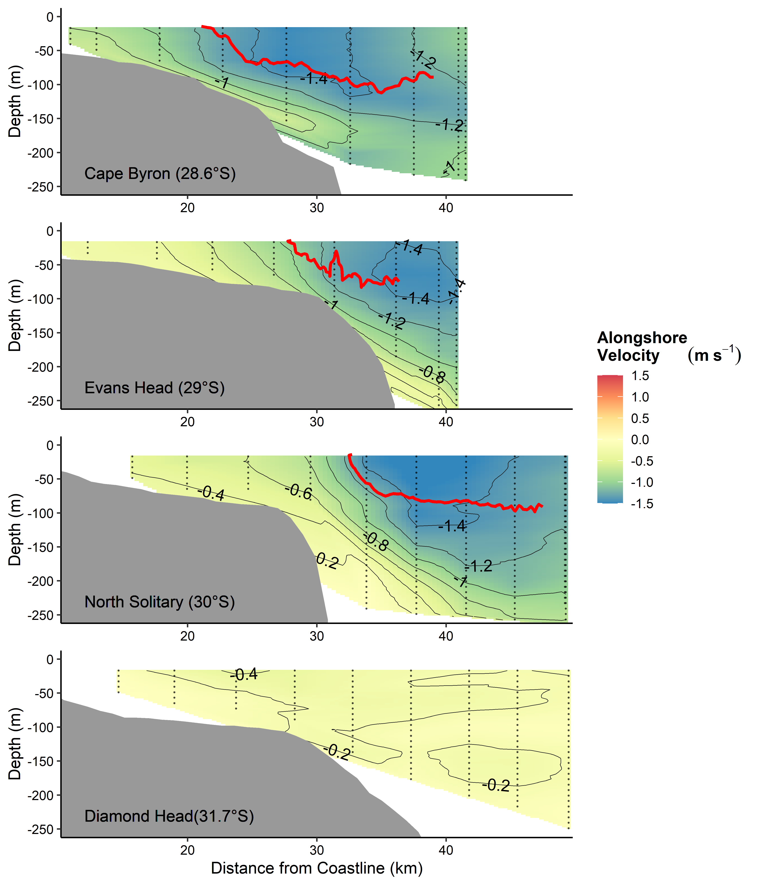

Figure 2 Alongshore velocity across the four cross shelf transects (Figure 1). Transects were conducted with an Acoustic Doppler Current Profiler during a CTD Transect. Grey lines join areas of equal velocity. The red line shows the 21°C isotherm based on the Bunyip transect. Note there was no 21°C isotherm for Diamond Head.

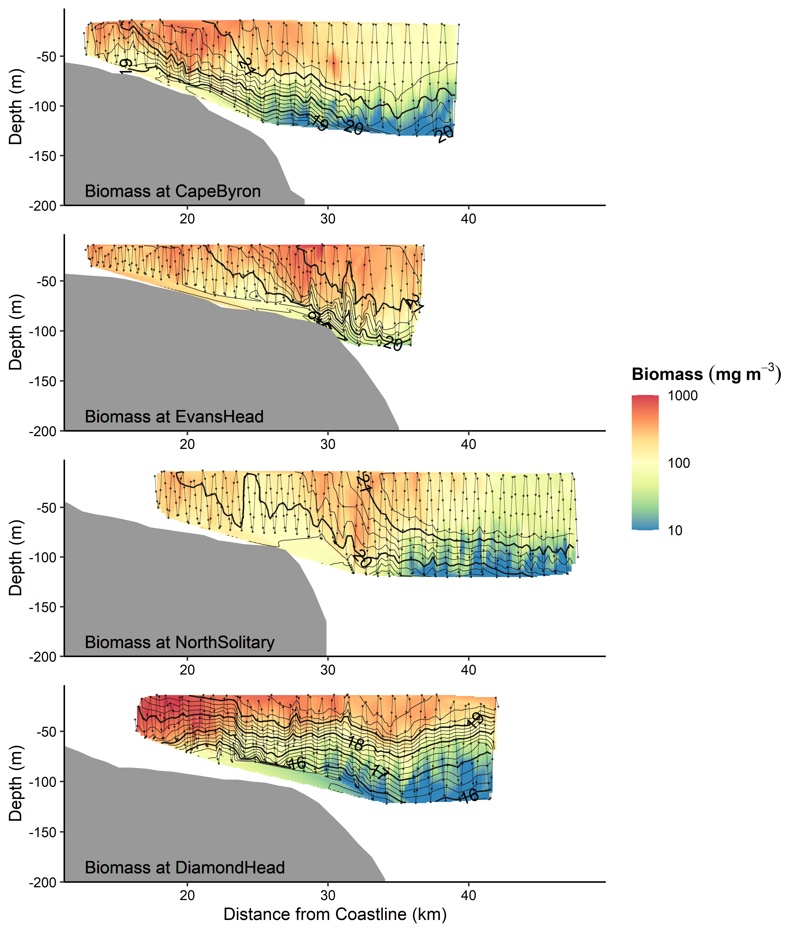

**Figure 3** Zooplankton biomass (mg m-3) distributions from the four cross shelf transects (Figure 1). Transe**c**ts were conducted form inshore to offshore with an undulating towed body with the path shown by the grey line with midpoints of each sample shown as dots. Temperature (°C) isotherms are shown in black. Note the log transformed colour scale.

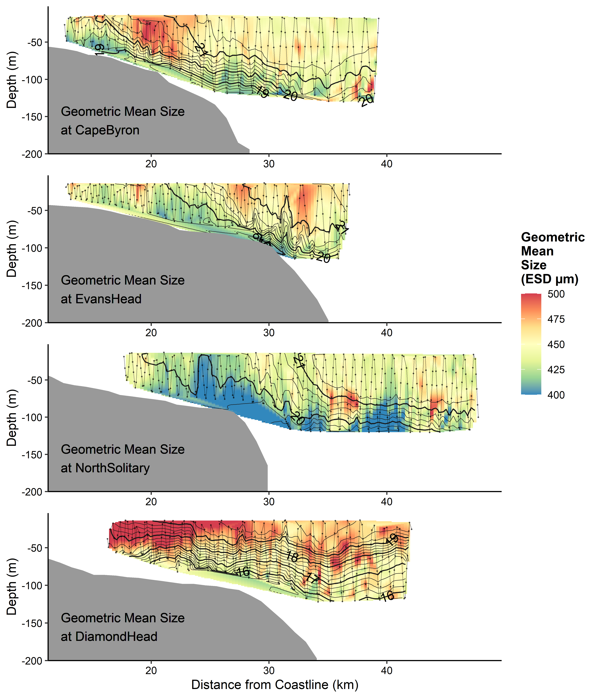

**Figure 4** Geometric Mean Size (µm equivalent spherical diameter) of zooplankton from the four cross shelf transects (Figure 1). Transects were conducted form inshore to offshore with an undulating towed body with the path shown by the grey line with midpoints of each sample shown as dots. Temperature (° C) isotherms are shown in black.

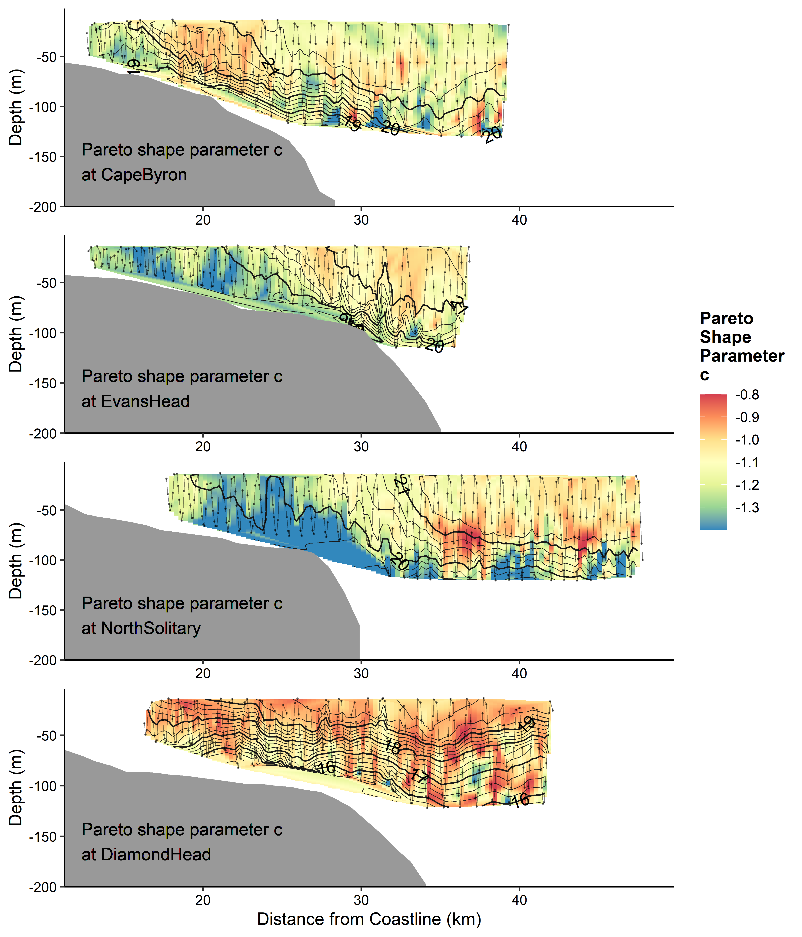

**Figure 5** Interpolations of the shape parameter *c* from the Pareto distribution of zooplankton size from the four cross shelf transects (Figure 1). This is an estimate of the normalised biomass size spectrum slope. Transects were conducted form inshore to offshore with an undulating towed body with the path shown by the grey line with midpoints of each sample shown as dots. Temperature (° C) isotherms are shown in black.



**Figure 6** Seasonal changes in mean alongshore velocity at the Cape Byron (28.6° S), Evans Head (29° S), North Solitary Island (30° S) and Diamond Head (31.8° S) based upon 10 years of satellite altimetry data (2004 – 2013). Velocity data was downloaded for the eastern edge of each transect (Table 1) from the IMOS Data Portal (<http://imos.aodn.org.au/imos/>). The EAC separates from the coastline varies between approximately 28° S and 32° S (Cetina-Heredia *et al.*, 2014).

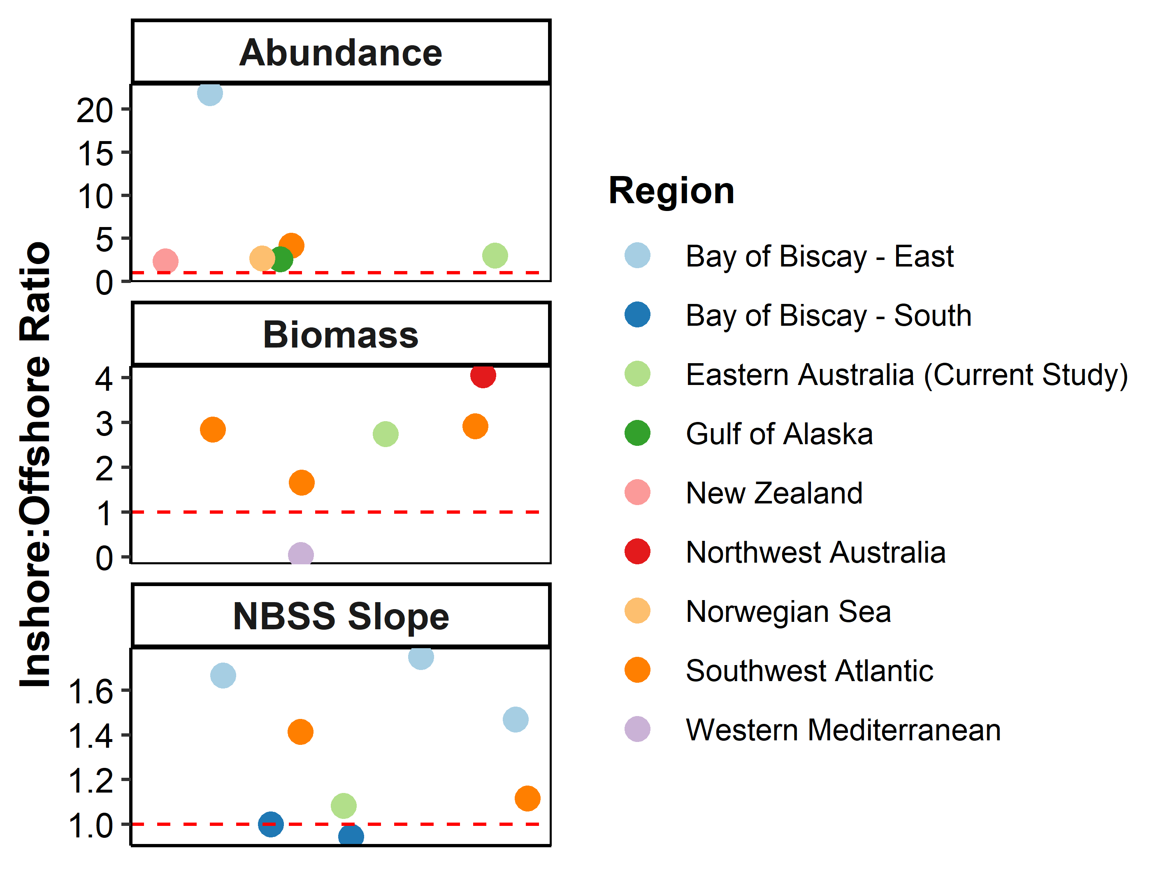

**Figure 7** Summary of all previous studies investigating cross shelf patterns of zooplankton (Table S1). The y-axis shows the ratio of the inshore to offshore reported values for Abundance, Biomass and the NBSS Slope. A value greater than 1 mean that the inshore region had a larger abundance/biomass or steeper NBSS slope. Each dot represents a study except for the studies in the Bay of Biscay which identified east and south as distinct region so they remain independent (Irigoien *et al.*, 2009; Vandromme *et al.*, 2014). Colour represents the study region. Note the differing y-axes. A jitter was applied to the x-axis to improve clarity and as such the x-axis is meaningless.

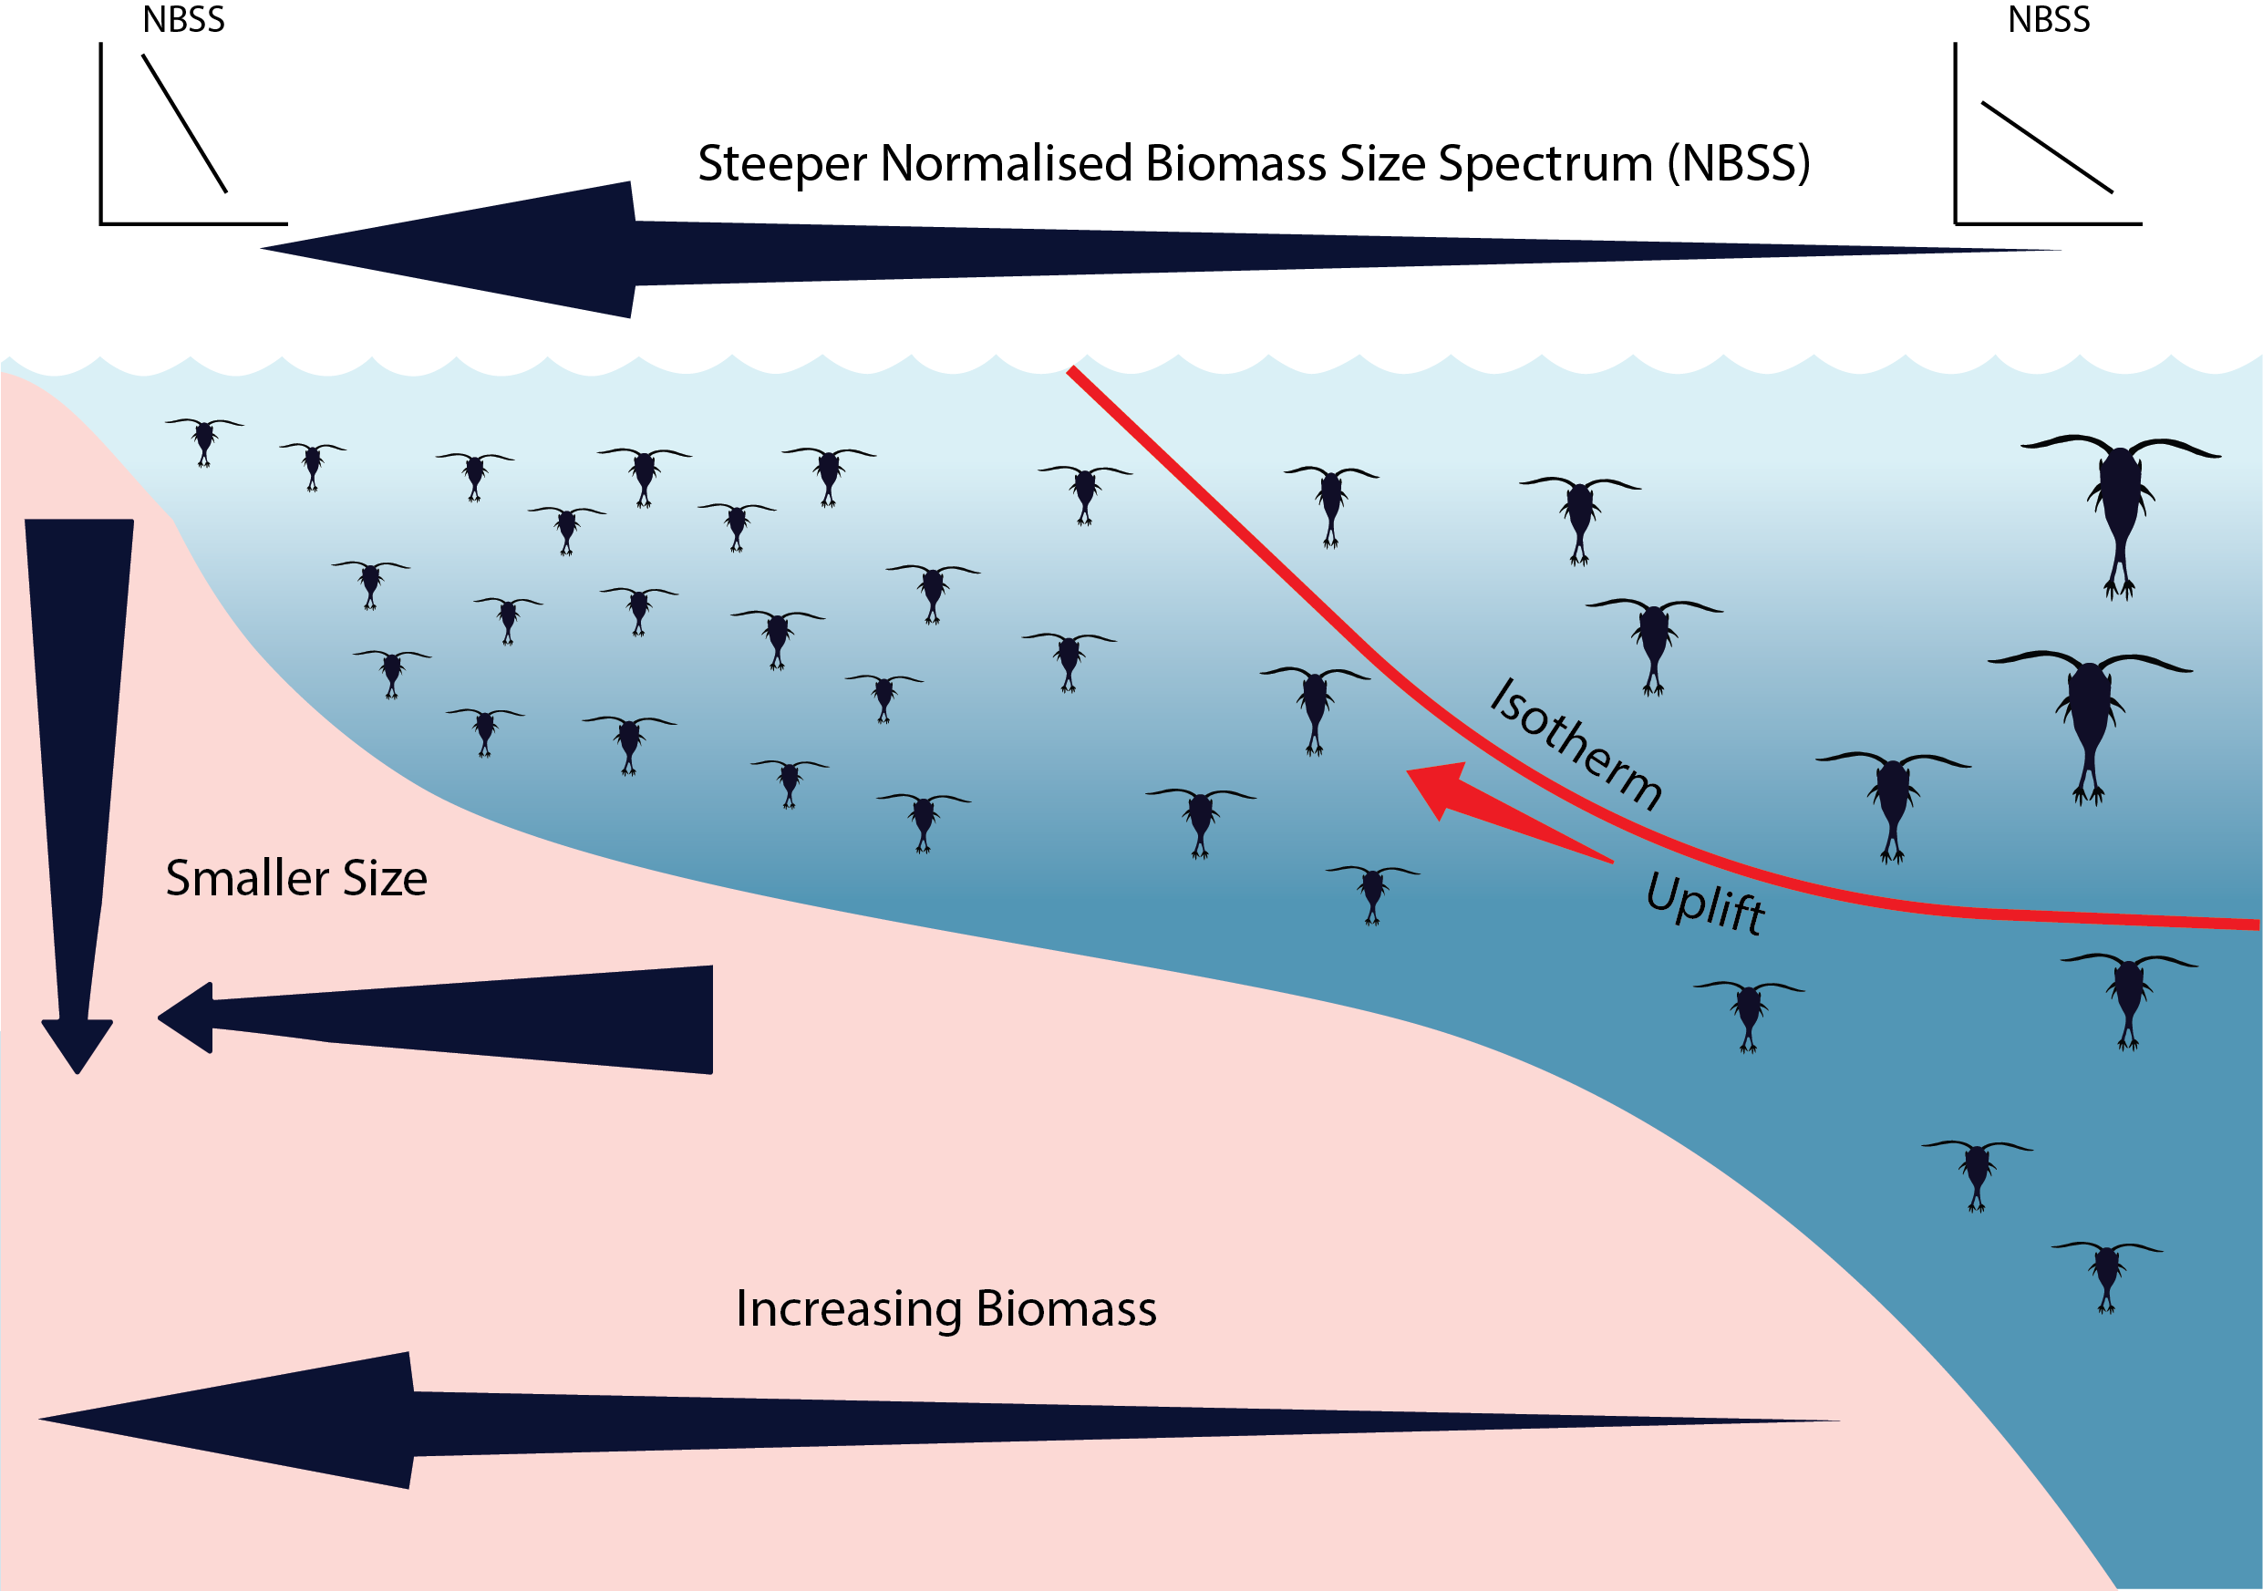

**Figure 8** Idealised concept diagram of the zooplankton community and how it changes over a continental shelf and with depth. Note all zooplankton are represented by copepods in this image.

**Supplementary Material**

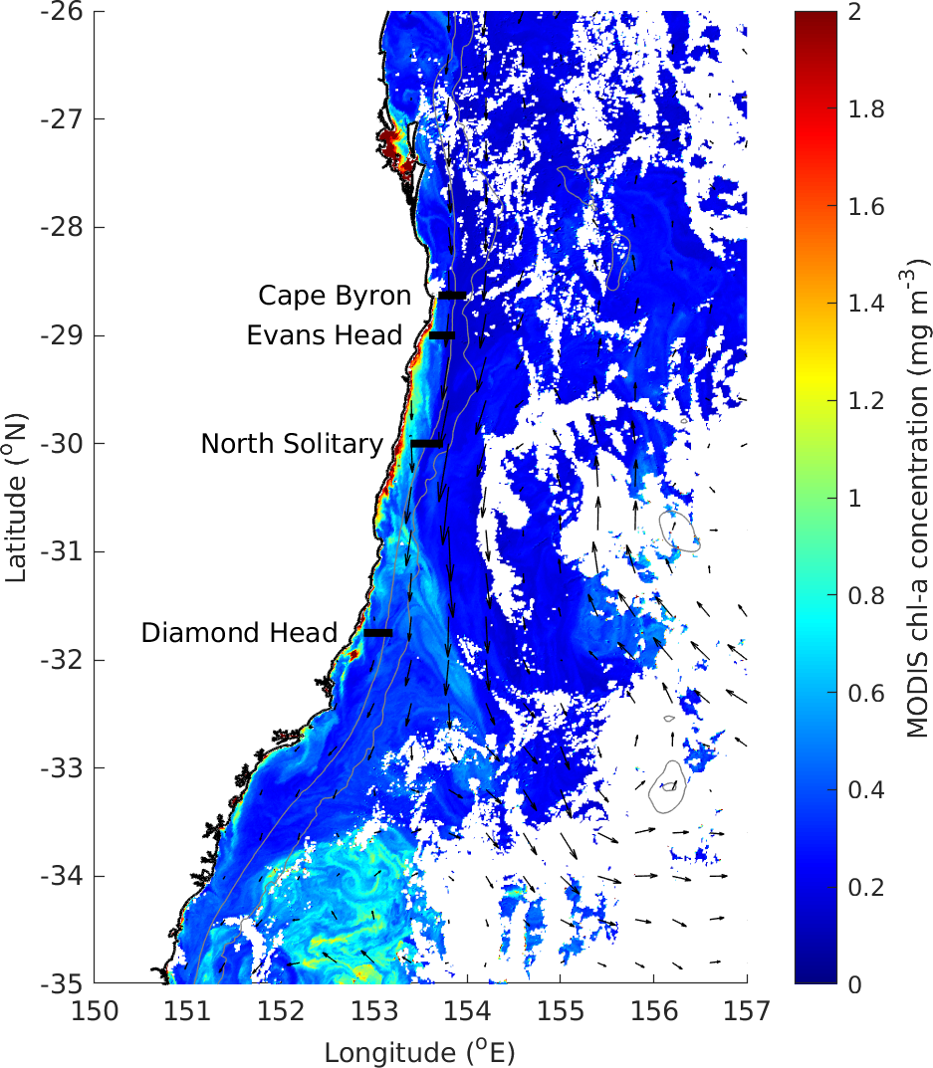

**Figure S1** MODIS Chlorophyll *a* (mg m-3) in the region during our study showing low amounts of Chlorophyll at all the transect sites (black lines) during our study.

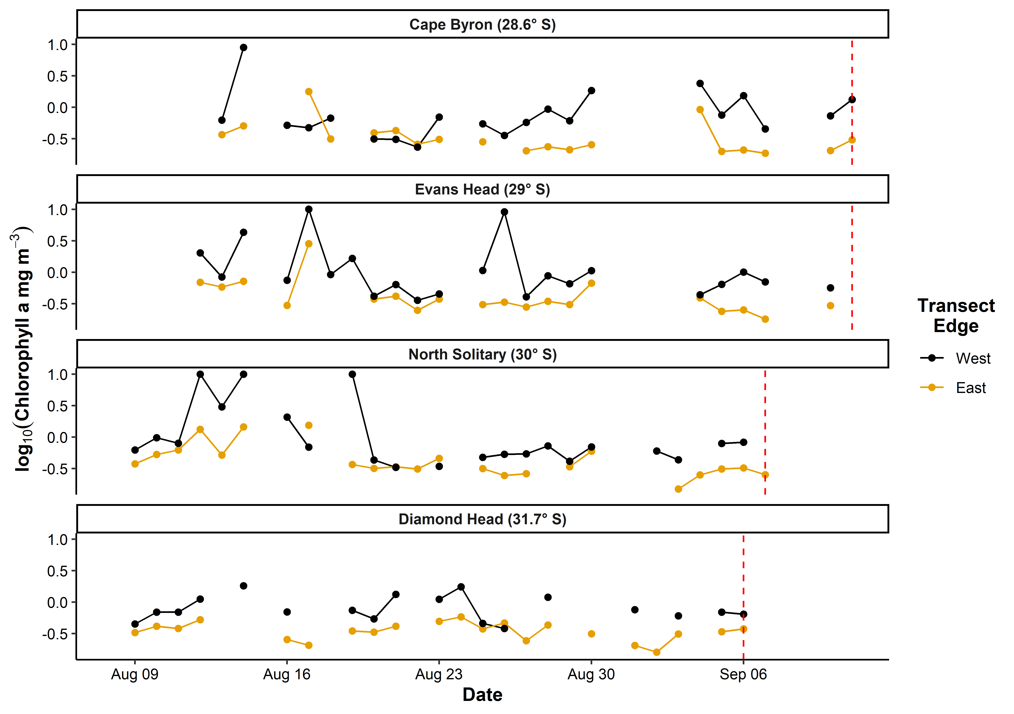

**Figure S2** Satellite observed chlorophyll *a* in the month prior to each transect based upon a 10 x 10 km region around the western and eastern edges of each transect. Gaps are due to days with no data due to cloud cover. The vertical red line shows the day each transect was sampled.

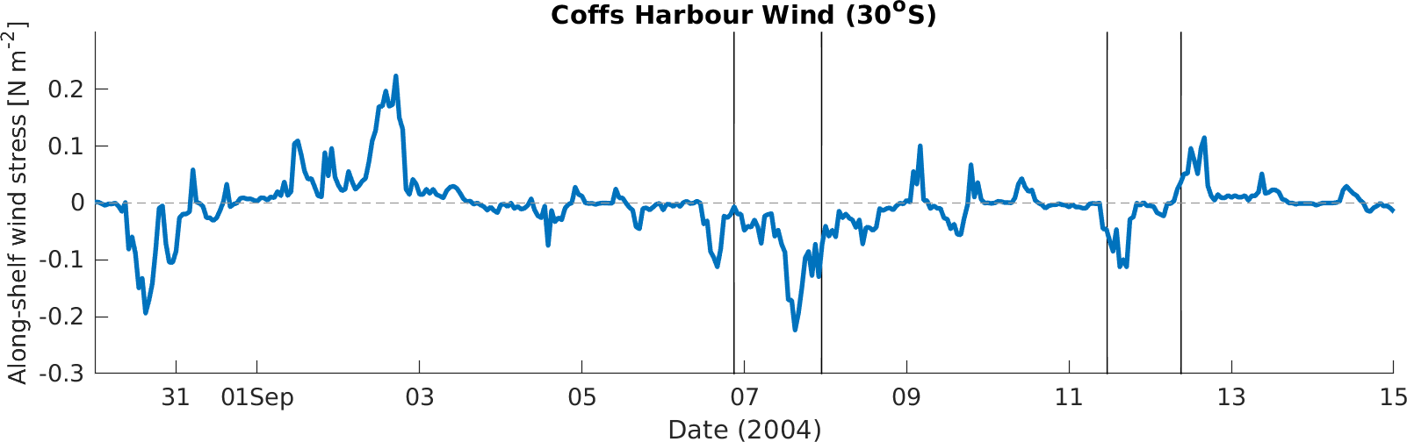

**Figure S3** Time-series of along-shelf (northward) wind stress component calculated from the observed wind at Coffs Harbour (30° S, local time). Negative values show upwelling favourable winds. The vertical black lines show the times of the 4 transects in this study.

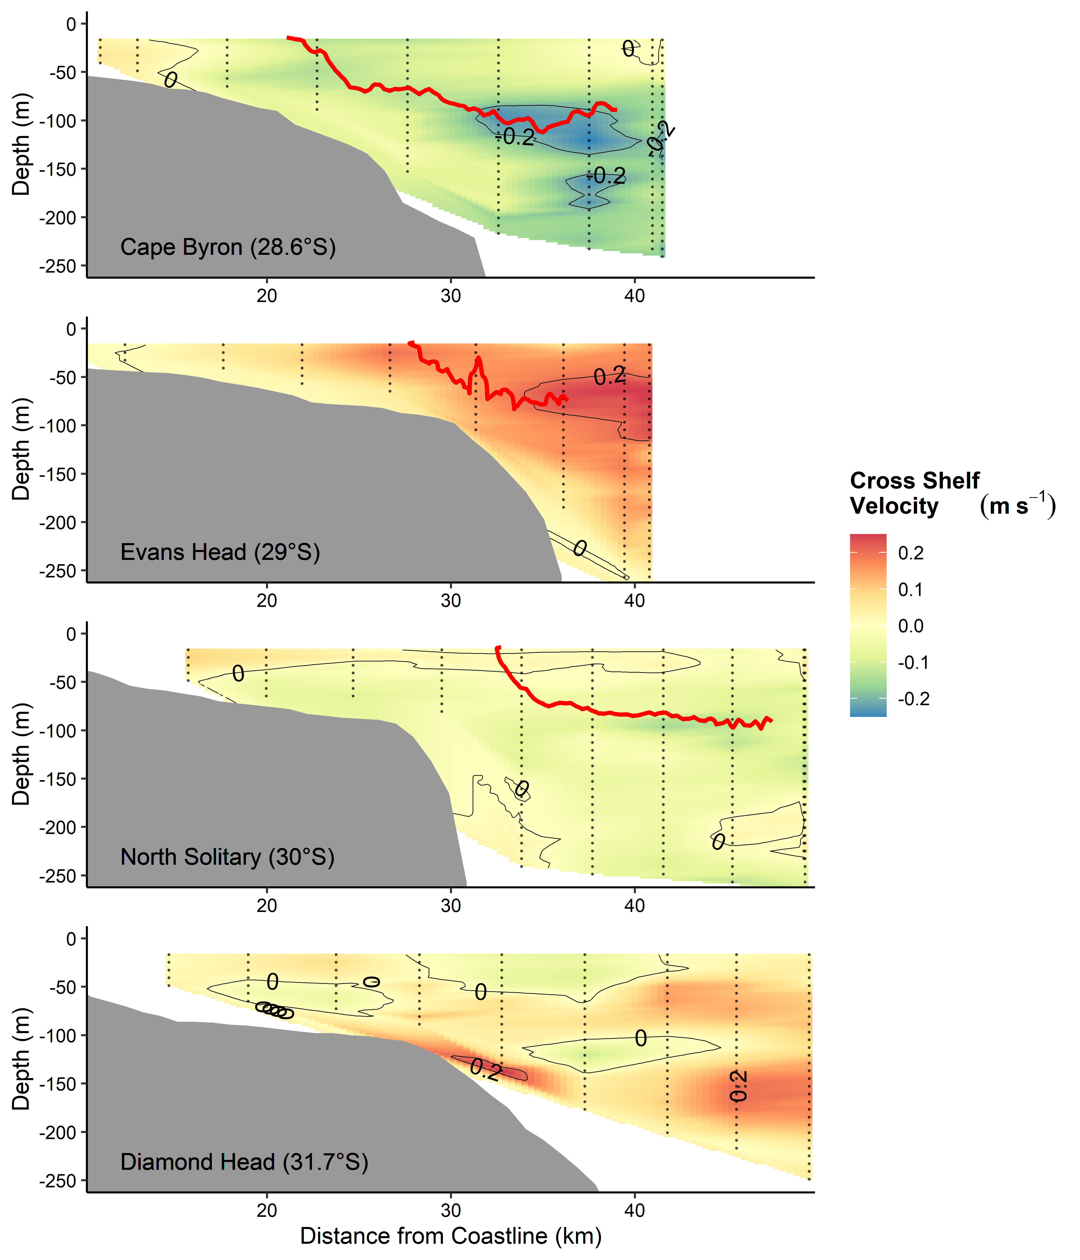

**Figure S4** Cross-shelf velocity across the four cross shelf transects (Figure 1). Transects were conducted with an Acoustic Doppler Current Profiler during a CTD Transect. Grey lines join areas of equal velocity. The red line shows the 21°C isotherm based on the Bunyip transect. Note there was no 21°C isotherm for Diamond Head.

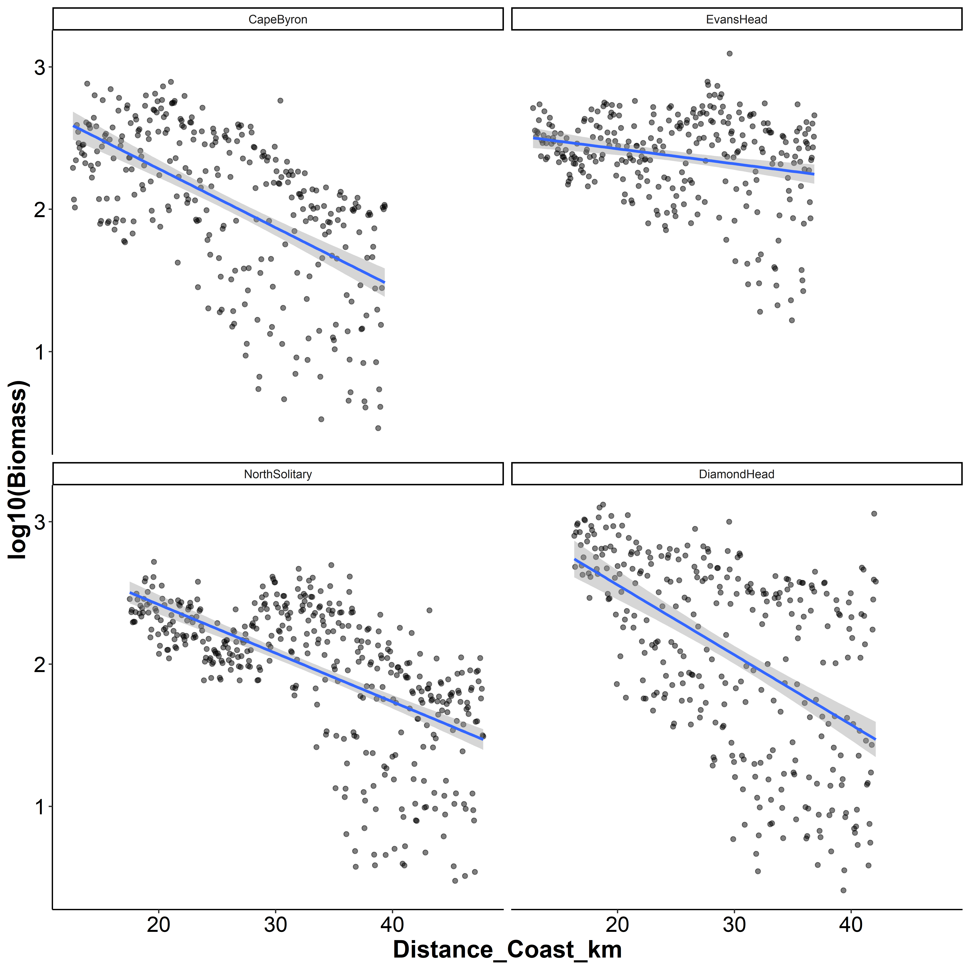

**Figure S5** Log10(Biomass) by distance from the coast for the four transects. Each dot represents a 6 s integration from the OPC mounted on the undulating towed body. Blue lines represent the linear trend line with the 95% confidence intervals shown in grey.

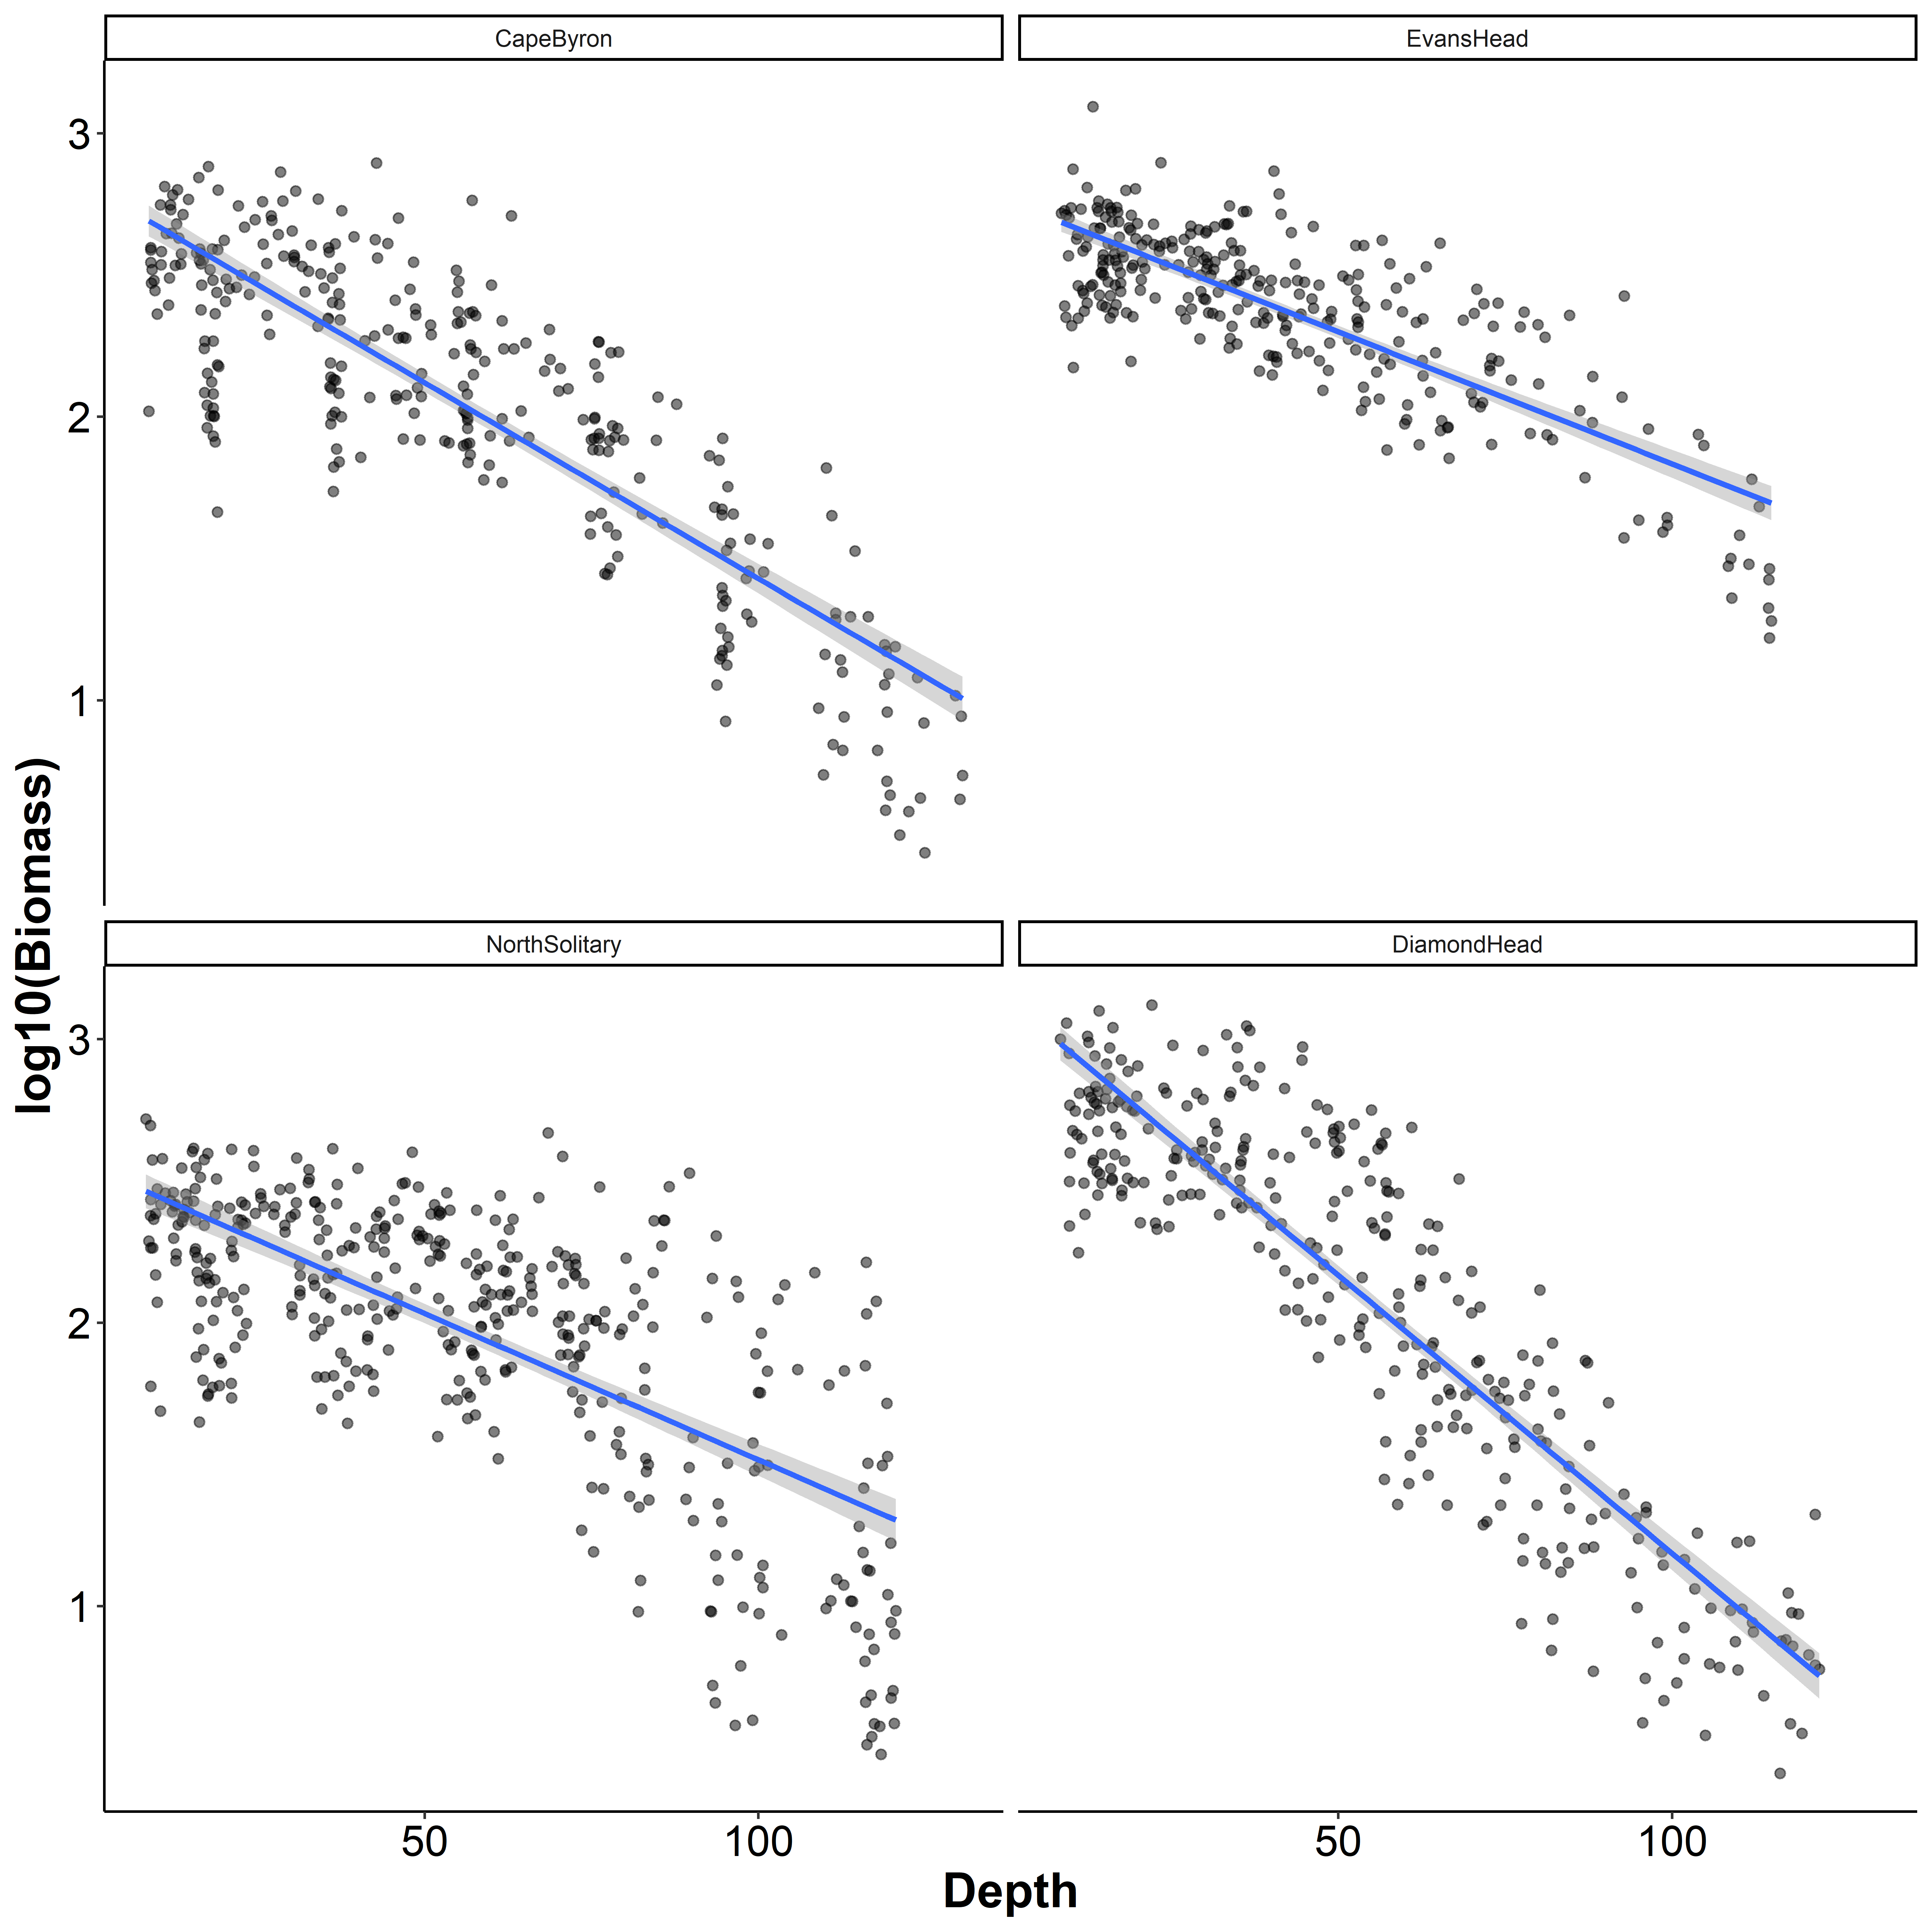

**Figure S6** Log10(Biomass) by sample depth for the four transects. Each dot represents a 6 s integration from the OPC mounted on the undulating towed body. Blue lines represent the linear trend line with the 95% confidence intervals shown in grey.

**Table S1** Details of the additional studies used in the global summary of inshore-offshore zooplankton patterns.Empty cells represent no data.

|  |  |  |  |  |  |  |  |  |  |  |  |  |  |
| --- | --- | --- | --- | --- | --- | --- | --- | --- | --- | --- | --- | --- | --- |
| **Study** | **Region** | **Latitude (°)** | **Longitude (°)** | **Inshore Biomass (mg m-3)** | **Offshore Biomass (mg m-3)** | **Biomass Ratio** | **Inshore Abundance (ind. m^3)** | **Offshore Abundance**  **(ind. m^3)** | **Abundance Ratio** | **Inshore NBSS Slope** | **Offshore NBSS Slope** | **NBSS Slope Ratio** | **Notes** |
| Becker et al 2018 | Southwest Atlantic Santa Catarina shelf | -28 | -47.5 |  |  |  | 2406 | 580 | 4.15 |  |  |  |  |
| Beckley 2018 | NW Australia | -15.5 | 122 | 1.34 | 0.33 | 4.06 |  |  |  |  |  |  | biomass converted from ml m-3 |
| Coyle & Pinchuk 2005 | Gulf of Alaska | 59 | -149 |  |  |  | 267 | 103 | 2.60 |  |  |  |  |
| Irigoien et al | Bay of Biscay - East | 45.5 | -1.5 |  |  |  |  |  |  | -1.25 | -0.75 | 1.67 |  |
| Irigoien et al | Bay of Biscay - South | 43.7 | -2.5 |  |  |  |  |  |  | -0.75 | -0.75 | 1 |  |
| Lopes et al 2006 | Southern Brazilian Shelf | -25 | -46 | 0.35 | 0.12 | 2.92 |  |  |  |  |  |  | highest biomasses from intrusions |
| Marcolin et al 2013 | SE Atlantic - Abrolhos Bank | -18.5 | -39 | 162.9 | 57.3 | 2.84 |  |  |  | -0.96 | -0.86 | 1.12 |  |
| Sabates et al 1989 | Western Mediterranean | 42.5 | 2 | 5 | 100 | 0.05 |  |  |  |  |  |  | strongly related to front. |
| Skarðhamar et al 2007 | Northern Norway | 69.5 | 17 |  |  |  | 2000 | 750 | 2.67 |  |  |  | also high at front. |
| Sourisseau & Carlotti 2006 | Bay of Biscay - East | 45.5 | -1.5 |  |  |  | 17500 | 800 | 21.88 | -1.25 | -0.85 | 1.47 | converted from ind. L-1 |
| Thompson et al 2013 | Southwest Atlantic | -45 | 58 | 47.9 | 28.8 | 1.66 |  |  |  | -0.58 | -0.41 | 1.42 | non-linear slopes offshore, smaller particles inshore |
| Vandromme et al | Bay of Biscay - East | 45.5 | -1.5 |  |  |  |  |  |  | -1.05 | -0.6 | 1.75 |  |
| Vandromme et al | Bay of Biscay - South | 43.7 | -2.5 |  |  |  |  |  |  | -0.85 | -0.9 | 0.94 |  |
| Zeldis & Willis 2015 | New Zealand | -36.6 | 175 |  |  |  | 877 | 377 | 2.33 |  |  |  |  |
| Schilling et al (This study) | Eastern Australia | -30 | 153.5 | 362 | 132 | 2.75 | 7037 | 2340 | 3.01 | -1.18 | -1.09 | 1.08 |  |